Contents

Global Economic Outlook Summary 2

Economic Outlook 3

Central Bank Policy Rate Watch 5

Forecasts & Strategy 6

Global Market Strategy 7

FX Strategy 13

Four global macro themes and top trades 16

J.P. Morgan FX Forecasts vs. Forwards &
Consensus 18

Fixed Income Strategy 19

Credit Strategy 23

Equity Strategy 26

Commodity Strategy 31

Volatility Strategy 34

The Economy
See page 42 for analyst certification and important disclosures, including non-US analyst disclosures.
J.P. Morgan does and seeks to do business with companies covered in its research reports. As a result, investors should be aware that the firm may have a conflict of interest that could affect the objectivity of this report. Investors should consider this report as only a single factor in making their investment decision. In the United States, this information is available only to persons who have received the proper option risk disclosure documents. Please contact your J.P. Morgan representative or visit http://www.optionsclearing.com/publications/risks/riskstoc.pdf.

World economy is rebounding from its Q1 sinkhole, but without payback, still below trend, and no faster than we had hoped. PMIs suggest upside into Q3, but they did so also in Q1, tempering our optimism. Central banks remain in no hurry to tighten.
Asset allocation
Our long-risk strategy remains based, not on strong growth, but instead on low growth, low vol, and low cash rates. Relative value has moved our credit OW to small, in favor of equities, commodity roll and EM. Macro momentum has shifted to EM as DM growth has been cut more. Greater macro risks on US growth and wage support being UW US equities, vs. EM, and FI vs. Euros.
Cross asset volatility
Maintain an overall short vol bias by selling 3-month straddles on CDX.HY. Open UK rate vol theme, buying front-end 2Y vs. 10Y gamma. Keep long GBP vs. EUR gamma but switch from the 5Y sector to greens. Take profit on Sep 14 USD/JPY put funded with a Nikkei put, and roll to 3M. Open long in Brent vs. Copper vol given geopolitical risk.
Fixed income
We retain our long-standing OW in Euro area duration vs. UK/US and OW Euro area periphery vs. core. Open 10Y US TIPS breakeven widener. Our systematic signals point to a long in 10Y Australia vs. Japan.
Credit
Spreads are close to pre-crisis lows, issuers are starting to lever up and credit is likely the more over-owned asset class. We have reduced our OW further from 5% to 2% vs. benchmark. Within credit, maintain focus on US HY and EM and now go long European HG financials vs. US HG.
Equities
Add to EM OW but focus the short leg on the US and Europe only. Recent price momentum in Japan and possible further policy action make a Japanese equity UW unattractive. Take profit on Euro area periphery and banks as valuations are no longer attractive and litigation risks remain high.
Currencies
We see dovishness at Swedish and Norwegian central banks and are short SEK vs. EUR and NOK vs. EUR and GBP. Also stay long EM FX.
Commodities
Upgrade commodities to OW on attractive carry, rebounding PMIs in China and supply risks in energy. Focus on energy for attractive roll and as a hedge to any supply disruption in the Middle East.

Global Economic Outlook Summary
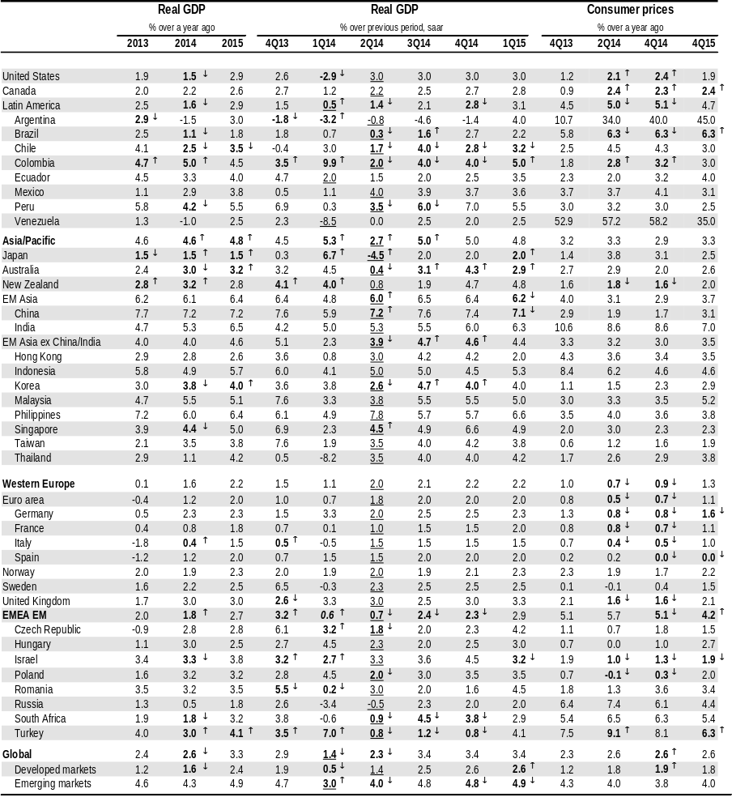
Note: For some emerging economies seasonally adjusted GDP data are estimated by J.P. Morgan.
Bold denotes changes from last edition of Global Markets Outlook and Strategy, with arrows showing the direction of changes. Underline indicates beginning of J.P. Morgan forecasts.
Source: J.P. Morgan

Economic Outlook
- The 1Q global growth sinkhole has deepened.
- Our global PMI and nowcaster are surging into midyear.
- Inflation is turning up, but recent moves overstate trend shift.
- Divergences emerge in EM monetary policy moves.

A disconnect in top-down and bottom-up
The dramatic downward revision of US 1Q14 real GDP growth to -2.9% (q/q, saar) deepens the early year growth dip. With the US delivering its weakest non-recessionary outcome in the post-World War II era, last quarter’s global GDP gain of just 1.4% annualized is the lowest of the expansion. Incorporating this result into our forecasts sends a sobering message. At 1.5% and 2.6%, respectively, US and global growth for the year (4Q/4Q) are now projected to slow relative to last year to a pace that is below potential. Such an outcome would be bewildering given that the largest drags weighing on the global economy last year have been fading. Fiscal and deleveraging drags are waning across the developed economies, while financial conditions more broadly are improving as the volatility from last year’s “taper tantrum” has subsided. At the same time, global monetary policy remains near the easiest it has been in the history of modern central banking.
Indeed, a global economy that is unable to expand above its potential under such conditions contrasts with the narrative we wove at the start of the year. The message from an important set of global data we track—industrial production, retail spending, labor markets, and surveys of business and consumers—also sends a contrasting signal. They pointed to global GDP accelerating in the second half of last year followed by some moderation at the start of this year. Specifically, these indicators correctly signaled two sources of disappointment: weak EM domestic demand and global inventory investment. However, from the perspective of our top-down indicators, the early year growth dip should have been mild and followed by a reacceleration into midyear. Indeed, our global nowcaster has tracked 1H14 global GDP growth at an above-trend 3.4% pace. While this contour was borne out in official data, the magnitude could not have been more different. The gap between this reading and our bottom-up GDP forecast at 1.8% marks a two-standard-deviation miss in our model and is the widest in the model’s history back to 1998.
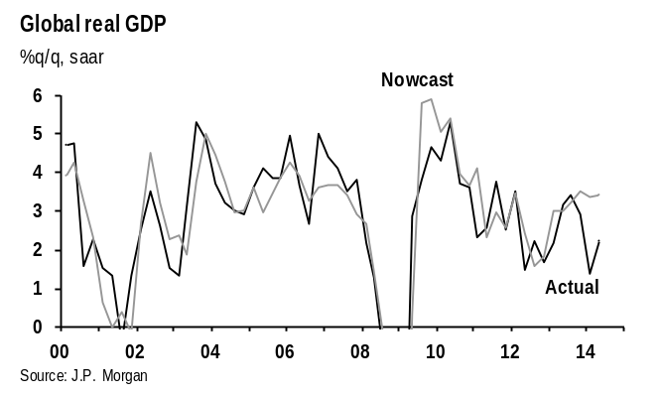
There are two possible explanations for this gap. One is that the dip in global growth has been unusually concentrated in sectors—services, construction, and government spending—that mostly lie outside of the global indicator flow. The sources of weakness in US growth provide only limited support for this view. While construction activity was very weak, services GDP expanded during 1Q. A second explanation relates to measurement error. The striking contrast in the US between the contraction in the demand for goods-producing industries—reflected in a large inventory drag and a decline in exports and spending on capital equipment—is hard to reconcile with the solid tone reflected in industrial production, durable shipments, the manufacturing surveys, and labor market data.
While there is no doubt that activity accelerated into midyear, the latest signs suggest the lift will still leave the global economy tracking light through 1H14. Even excluding the VAT-induced drop in Japan, neither our top-down nor bottom-up indicators point to a bounce that would reconcile 1H14 growth with our macro views.
If there is any comfort to be taken from this disquiet, it lies in the recognition that policymakers and markets are generally discounting the message from GDP reports. This is evident from the June FOMC meeting, where a 0.7% downward revision to the 2014 growth forecast received little attention. At the same time, that both the global manufacturing and services PMIs appear to have risen in June suggests global real GDP is accelerating to a boomy 4.2% annualized pace this month, as filtered through our nowcaster. How much weight to put on this following the huge negative errors in these trackers early this year is a key question, but for now we are taking them as encouraging signs of rebound from a first quarter we would like to forget.

An upside global inflation surprise
Our 2014 outlook anticipated that a three-year disinflationary trend would end and expected global inflation to rise about 0.5%-pt from its early year lows. Consumer prices rose 2.6%oya in May according to our preliminary estimate, reaching our year-end target much faster than expected.
The upturn in inflation is not due primarily to the VAT hike in Japan. Outside Japan global inflation also has climbed from 2.1%oya in February to 2.5%oya in May. And the surprise we are seeing does not appear to reflect commodity price movements, as retail energy and food inflation have evolved more or less in line with expectations. Oil prices have firmed over the past year, even before last week’s jump, boosting retail gasoline inflation. Equally important, agricultural commodity prices have moved off their lows following a roughly 33% slide from mid-2012 to early 2014. With a short lag, this has begun to temper the sharp disinflationary pull from food prices.
It is the pickup in core inflation that has surprised us. The global economy expanded at a pace just above its trend over the past year. We would have expected this to produce stabilization or a slight rise in core inflation. Indeed, core inflation leveled off over the balance of the period, running 1.8% on a 12-month basis from May 2013 through early this year. However, this was followed by a significant increase in the past few months, with the core rate rising 0.3%-pt to 2.1%oya from February to May, or 0.2%-pt excluding Japan. The move up in core inflation is even more striking in sequential terms. Moreover, it is relatively broad-based outside of the Euro area, though with an especially strong contribution from the US.
To be sure, short-term movements in inflation can be volatile and the fundamentals do not support the rapid increase of the past few months. The global output gap is closing only slowly and there are scant signs of wage pressures, which are an important building block in the inflation process. With that said, the strength and geographic breadth of the recent move suggest firms are regaining some pricing power. This may reflect the fact that global manufacturing has been growing at an above-trend 4% pace for a full year now. Although the monthly rate of inflation is likely to cool, our hunch is that pricing power will continue to firm and that core inflation will track somewhat above our forecast, producing a further modest increase in the year-ago inflation rate during 2H14.

Asia less able to join axis of easing
In recent weeks, several EM central banks have eased monetary policy and others look to be getting ready to do so. Much of this is in response to softer growth, calm financial markets, and continued easy monetary conditions
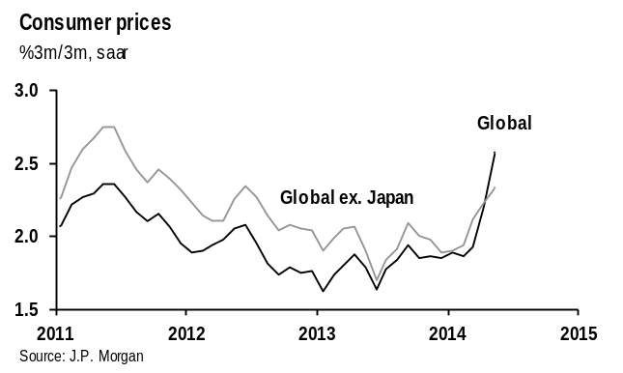
in the developed world. The shift mostly has been seen across Latin America and in EMEA EM. Last week, Turkey’s central bank surprised with a 75bp cut even as it creatively defined “tight monetary policy” as the maintenance of a flat yield curve. Assuming financial markets stay calm and the lira remains stable, we look for further CBRT easing.
In contrast to the easing bias in other parts of the EM, supply constraints and financial vulnerabilities in EM Asia are pushing central banks to either stay put or tighten policies. The PBOC is an exception. Officials are likely to keep to their annual credit target of 13% growth but with easier financial conditions allowing CNY to stay on the weak side longer and interbank rates soft to support exports and domestic demand. And although we look for across-the-board RRR cuts, this is mostly in response to the reduction in FX intervention. Similarly, the BoK is expected to remain on hold for the rest of 2014 despite soft growth and inflation even if some limited selective credit easing measures are possible.
Elsewhere in EM Asia, central banks are leaning toward a tightening bias in response to financial stability concerns and rising inflation pressures. We look for further rate hikes from the Philippines and the start of hikes from Malaysia in July. Although Indonesia’s central bank is expected to stay on hold, the risks to the policy outlook are tilted to the upside should the current account deficit widen or the currency weaken materially. In Thailand (the only central bank in the region to have eased this year), policy has also shifted to a neutral stance given price pressures. Singapore’s monetary authority has kept its currency on a modest appreciation path since April 2010 as upside risks to core inflation remain material. Similarly, upside inflation risks from a subpar monsoon will likely limit the Reserve Bank of India’s patience as the government tries to implement its reform agenda, and so we still look for a hike by year-end.

Central Bank Policy Rate Watch
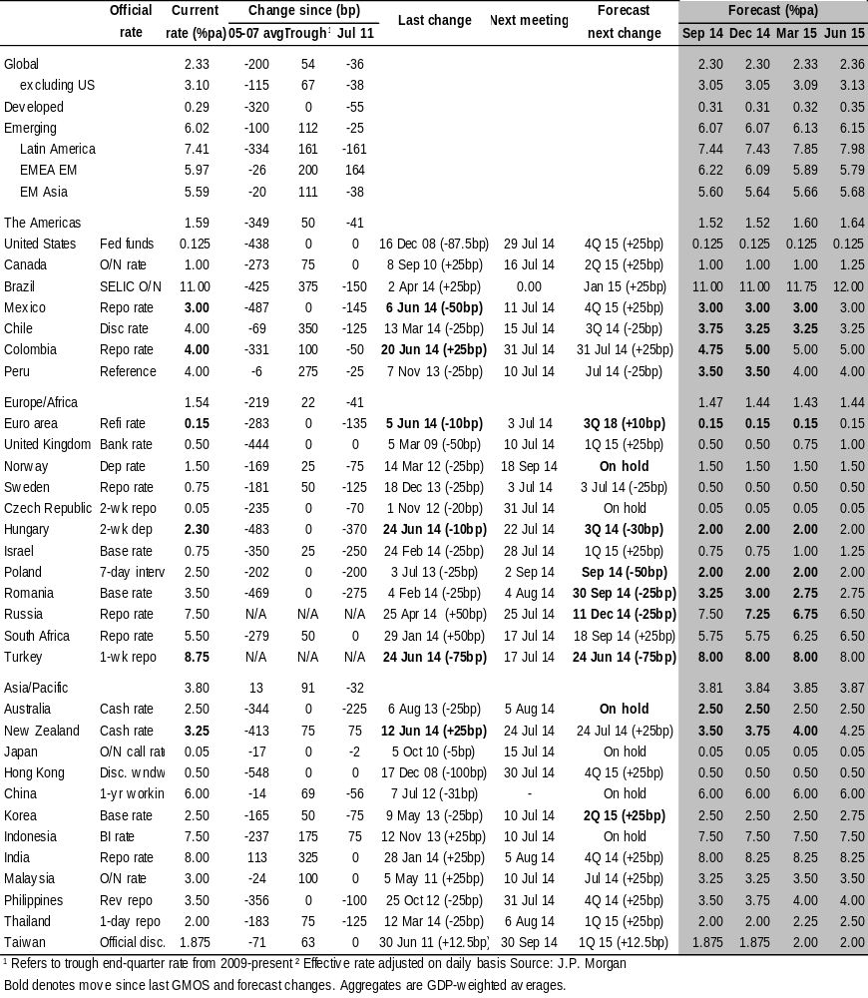
¹ Refers to trough end-quarter rate from 2009-present ² Effective rate adjusted on daily basis. Source: J.P. Morgan
Bold denotes move since last GMOS and forecast changes. Aggregates are GDP-weighted averages

Forecasts & Strategy
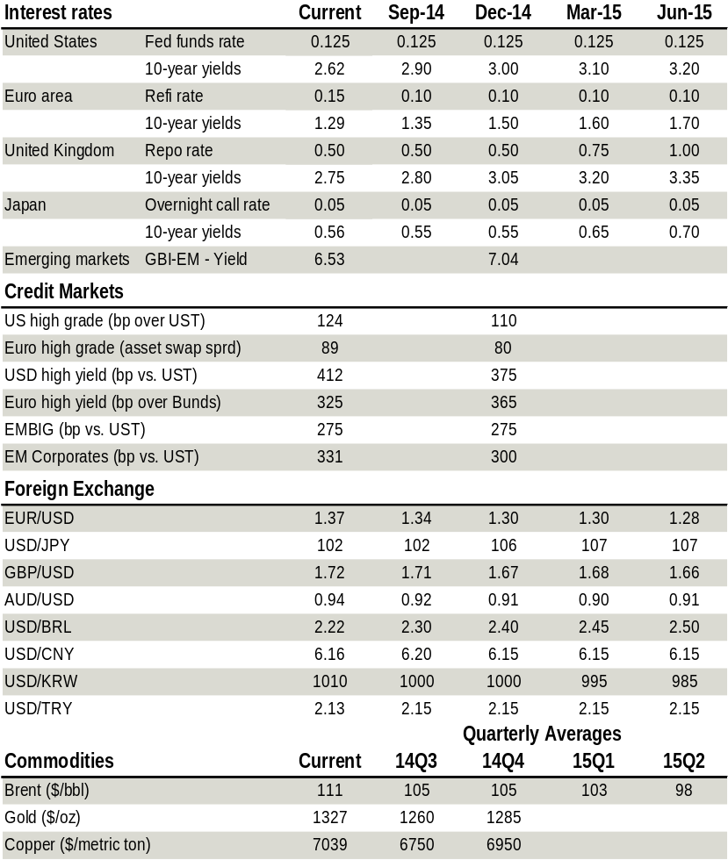  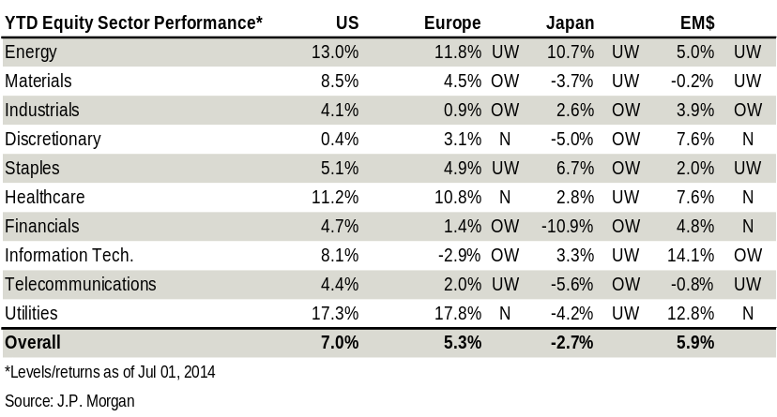 | Investment themes and impacts  Source: J.P. Morgan  Tactical overview  Source: J.P. Morgan
  Low growth means money stays easy
  The current US recovery is the slowest since WWII. Global growth will barely exceed potential. Easy money stays for a long time.
  Low macro vol drives carry trades
  ZIRP and low macro vol make earning risk premia and carry very attractive.
  Rotate risk from over-owned and -valued
  … to better valued and less owned risk assets. Credit OWs are now small, and exposure is moved to equity, EM and commodity roll.
  OW EM across asset classes
  Relative macro momentum is switching to EM. EM growth expectations are stabilizing while those in DM have come down badly. Investors seem UW EM, while it offers better value. OW EM across bonds, FX, credit and equities.
  Avoid and hedge what is suspect
  Our UWs are not just based on value and macro momentum but also on what seems uncertain, coming from event risk, such as the Middle East and China, or from the unexplained (fall in U-rate and Q1 GDP). Hedges include oil futures, UW US FI vs EU, UW US equity vs EM.
  Past half-time in the global business cycle
  June marks the 5th anniversary of the recovery. Working hypothesis is an 8-year recovery. That keeps the equity rally on track, but makes the credit rally mature.
   | Direction | Country | Sector
  Asset allocation | Bullish risk | EM | OW Equities, HY vs bonds,
  Equities | Long | EM, Dax | Semiconductors; J-REITs; cycl’s
  Bonds | Flat Duration in DM; long in EM | EU vs. US, UK. OW, NZ, Spain; AU, Brazil.
  Credit | Small OW | EU | HY, FINs, EM.
  FX | Long EM | Carry from: COP, CNY, PHP, NGN | Long SEK, NOK vs. EUR; short ZAR vs. USD.
  Comd’s | Small long |  | Brent on carry; Copper on better demand from China .

Global Market Strategy
- Our core strategy remains based on low macro volatility and easy money and keeps us long risk premia and carry.
- Relative value and relative risk are the main drivers of allocations across countries and risk asset types.
- Our main value consideration is that credit spread tightening seems mature and thus less attractive than risk premia in equities, commodity roll and EM. By now our credit OW is small, and we have comparatively larger longs in equity, commodity and EM risk.
- Relative downside from event risks (Middle East) or simply the unexplained (US Q1 growth and US jobs growth) lead us to be long energy commodities futures, and UW US bonds and equities versus Euro and EM.
- We remain overall long EM through FX, credit, local bonds and equities, on value, relative risk, and the reversal in relative macro momentum towards EM.
Markets continue to perform broadly on plan, with stocks hitting new historic highs, bonds and credit spreads in a range, and EM on net outperforming. Against forecasts, the dollar weakened, likely on the massive downgrade on US Q1 GDP growth.
At the core, our long-risk strategy of the past few years has not been based on a bullish growth view, but instead on a bearish view on volatility and uncertainty against what we consider to be still attractive risk and yield premia in the presence of no return on cash. In recent months, we have combined this with a rotation across risk assets from what we considered relatively over-owned and valued risk assets – primarily credit – towards relatively under-owned and under-valued risk assets – EM and commodity roll.
This strategy – net long risk assets plus risk rotation – continues to work well and underlying conditions remain supportive, in our mind. But anytime one counts on low volatility and uncertainty, one needs to be constantly on the lookout for what can disturb this quiet. At the macro level, disturbances can come from surprises on growth, inflation, company actions, policy and politics. Most measures of delivered macro volatility and surprises are showing that little new seems to be hitting markets. In our sister publication, Flows & Liquidity, Nikos Panigirtzoglou
Figure 1: Global GDP Forecast Revision Index Volatility
%, 12-month rolling standard deviation of index of JPMorgan Global GDP growth forecast for current and next year.
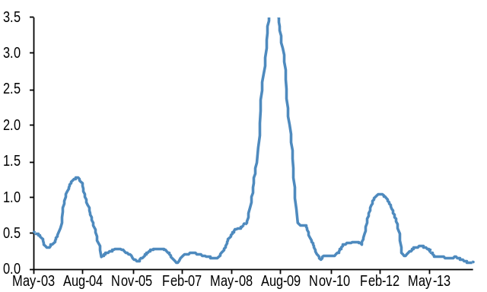
Source: J.P. Morgan
Figure 2: A proxy for US monetary policy surprises
NBER recessions in shaded areas, 3m stdev of daily changes of the difference between the 3m US OIS rate 2y forward minus the spot 3m OIS rate.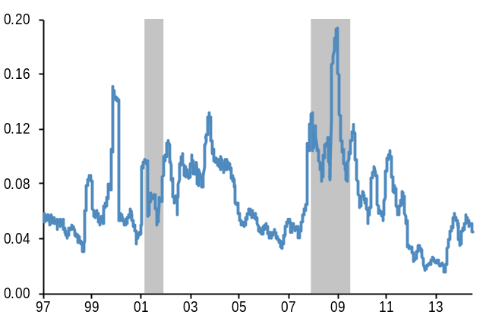
Source: J.P. Morgan
shows that economic growth and company earnings volatility are at historic lows. Figure 1 shows that the rolling 1-year volatility of our global GDP Forecast Revision Index has fallen to a 12-year low point.
In contrast, US monetary policy expectations have grown more volatile, even as they remain near the lows of previous cycles (Figure 2). And in the corporate world, credit ratings actions and credit watches are steadily increasing (Figure 3). Higher delivered volatility on monetary policy and credit is keeping us out of trying to earn term premia in DM bond markets and is one contributing factor that has made us bring our corporate credit overweight to a small position.
Delivered volatility obviously only tells you about the past and by itself does not predict the incidence of future shocks. If anything, the mean reversion in volatility is a warning that volatility and uncertainty are bound to rise in the future, even as this tells us little about when. To some degree, forecasting future shocks is like forecasting surprises and is thus by definition impossible. If you could forecast a surprise, then others could also and its event would no longer constitute a surprise. Shocks that arrive like a sudden tsunami or earthquake cannot be predicted, except for highlighting where such natural events are more likely to occur.
But we can do better. One approach is to look at puzzles, disagreements, and disequilibria as a more likely area of future surprises. Another is to look at smaller disturbances as we find larger shocks typically start as smaller ones.
On the first, we look at areas where there are clear puzzles and where there is thus a higher chance of a different outcome than most expect. Two immediately come to mind and both are in the US: the unexplained fall in Q1 GDP and the wide gaps between US job growth and economic growth. At the start of the year, we and consensus expected a 2.5% growth for US Q1. The latest official estimate printed -2.9%, one of the largest misses ever. Still, equities have rallied during the last few months of downward revisions. This is likely because the Q1 miss does not appear to have a clear smoking gun and because jobs and earnings data were a lot better behaved that quarter. The markets in effect have ignored the GDP miss, but this still leaves a feeling of uncertainty and a discomfort that the US economy could just drop this badly with no clear explanation.
Also in the US, we have the continuing divergence between jobs and economic growth, with the unemployment rate now well below the level where Bernanke only last year mentioned he would consider starting the hiking process. There is so far little sign yet from wages that the US labor market is tightening up, but the mystery about whether the fall in labor participation is cyclical or structural adds to uncertainty about when the Fed will be forced to hike rates.
On the second source of risk, it is our experience that the shocks that really hurt you almost all start as small brushfires that keep growing as they have a lot of kindling around them – contagion – before either burning out or becoming a wildfire that consumes the block. The great majority of these eventually burn out. Unfortunately, there is no sure-fire way to tell which brushfire will burn out and which will get out of control. This requires discretion. The main smoldering risks that seem to be out there are the widening Sunni-Shia civil war in the Middle East; the unresolved rise in leverage in China; and deflation risks in the Euro area. On the former, we have no comparative advantage but find that there appears to be little local
Figure 3: Corporate credit actions
Average of total credit actions by Moody’s and S&P’s, including credit watches, 2014 figure is YTD annualized.
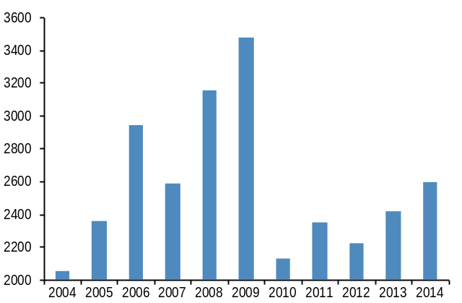
Source: Bloomberg and J.P. Morgan calculations
Figure 4: Chinese leverage
Total social financing / nominal GDP.
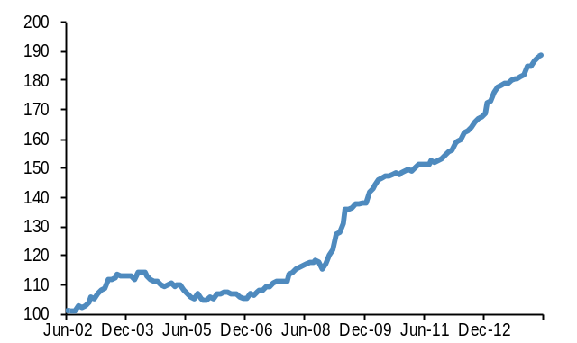
Source: J.P. Morgan
interest in compromise and instead ample willingness to add fuel and resources to the fire. Hence, we should assume that this brushfire is not going away fast and requires protecting against.
On China, the significant growth in leverage – debt rising much faster than the economy (Figure 4) – has created a time-inconsistency between its two main policy objectives, maintaining growth and liberalizing markets. The two clearly support each other longer term, but the dramatic rise in leverage creates the risk of a credit crisis, and thus a recession, if the markets are opened too fast. The desire to maintain growth around 7.5% is delaying efforts to delever the system, raising the ultimate risk of a credit crisis. So far policymakers have only managed to slow the pace of leverage growth. Investors look at China and feel they have seen this movie already, twice, during the US subprime and Euro sovereign debt crises. Hence, the market will continue to price in a hefty credit risk premium around Chinese equities. Our best guess is that a credit crisis in China remains a live risk, but is likely 1-2 years away.
On Euro deflation, investors and policy makers have taken notice, inducing the former to overweight euro duration and the latter (the ECB) to take preventative action. The ECB delivered last month more than expected with a -0.1% negative rate on deposits and a 4-year funding package for banks (LTROs) on condition they increase their lending. The main motivation of ECB easing was surely to cut off the growing risk of deflation in the Euro area. And this risk was also why we have been overweight euro bond duration versus the US and the UK since Q4. Deflation would be averted if the ECB succeeds in either driving the currency down (as the BoJ accomplished) and/or in pushing up aggregate demand. The euro is not moving, even as we still forecast it to edge down to $1.30 by yearend. Demand seems to be strengthening slowly and may even benefit from the new LTROs, but is in our mind not strong enough to eliminate deflation risk.
When a risk emerges, whether positive or negative, you have the choice of ignoring it, and even buying the assets hurt by it, or you can sell the assets most affected, either for similar ones further away (the UW/OW game), or against cash, thus reducing overall risk.
There is no fixed, simple rule on what you do in each case. We judge each shock on its own on whether it has a risk of growing and contagion. Most we let pass. The ones that do not go away soon lead us to underweight the area and sectors most vulnerable to them against similar risk assets further removed. We use the image of a stone thrown in a pond. The further you are from where the stone is tossed, the less affected you are. At times, there is clear risk of continued contagion and we actually reduce overall portfolio risk.
At this point, we are not inclined to reduce our overall exposure to risk assets as we do not judge our list of mishaps sufficiently threatening or imminent. But they do warrant taking evasive action. The puzzling slowing in US growth, even as it has largely been ignored by the market, does signal to us that this could happen again, as surprises tend to repeat. Underweighting the dollar and being long US duration would help, but conflicts with hedging against the earlier Fed risk scenario. We thus prefer underweighting the US equity market. We rather not do this versus Europe given still lingering deflation risks there and thus execute this by adding to our EM equity OW.
The main way one can hedge the risk of earlier US labor market tightening and thus Fed rate hikes is being long the dollar and short US duration. The latter is negative carry. We have instead chosen this year to be short US against euro duration, both to reduce carry costs and to combine with hedging against euro deflation, and we stay this way. Also, earlier and larger Fed hikes could create serious problems for the main carry trade that investors have been pursuing in recent years – credit. Together with our aim to rotate into better priced risk assets (see below), this has induced us to cut our credit OW to only a small position.
Hedging against contagion from the Middle East conflict requires being long crude. We were already there as we liked being long the high roll return from the backwardated oil futures curves and we stay this way. The China risk factor creates a more difficult problem and we have effectively decided not to hedge it as it conflicts with too many other ideas we are pursuing, namely better carry in EM assets and long the recent rebound in IP and Manufacturing PMIs.
Risk rotation: We are happy and stay with our advice from last month to rotate exposure from relatively over-owned and valued risk assets, credit, towards better valued and less-owned ones, commodity roll and EM. This position has worked, as credit spreads have been quite mixed (some up, some down), while equities, EM and oil have all performed well. Investor feedback on this advice has been mixed with some considering this rotation, but most have not pulled the trigger yet. Many investors remain averse to EM as they do not appear impressed by conditions on the ground, EM economies and assets have underperformed over the past few years, and they are considered vulnerable to eventual rate normalization in the US. In our mind, everything is relative. We are not yet upgrading EM growth, but our forecasts are now quite stable and we have cut DM a lot more (Figures 5-6). Relative macro momentum has in our mind thus shifted in favor of EM. The relative cheapness of EM currencies, bonds, credit and
Figure 5: J.P. Morgan 2014 GDP growth forecast: EM vs. DM
%.
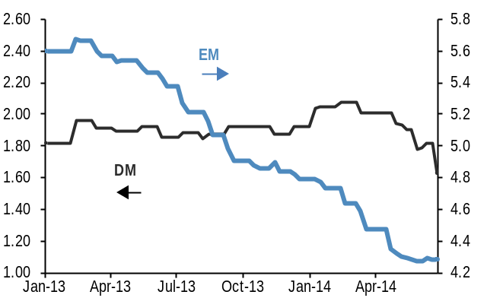
Source: J.P. Morgan
Figure 6: J.P. Morgan 2014 GDP growth forecast: EM - DM
%. Difference between J.P. Morgan EM and DM 2014 GDP growth forecasts.
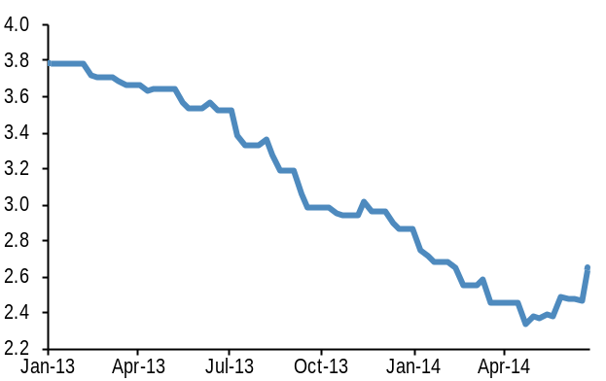
Source: J.P. Morgan
equities versus their EM equivalents, and the mature nature of DM credit spread tightening are added reasons for us to remain overweight EM across asset classes.

Long-only GMOS portfolio
Since last GMOS, our model long-only portfolio made 1.7%, outperforming the benchmark by 32bp, largely because of the heavy OW of equities. Since inception of this long-only portfolio in August 2012, the long-only GMOS portfolio has outperformed the benchmark by 4.1%. YTD, we have underperformed by 0.5%.

A significant overweight of equities and underweight of cash remains a strategic feature of our portfolio. Over the past few months, we have brought our Credit overweight down to only a small position (+2%) as spreads are close to cycle lows (last revision in The J.P. Morgan View, The Credit Decision, June 13). At some point over the next 6-12 months, we anticipate to be overall neutral on credit. But within credit, we put a greater allocation into higher-yielding product and EM. We also recently brought Commodities first to Neutral and then to a small OW, to add carry from commodity roll, as a hedge against the worsening of the civil war in the Middle East, and to position for the pickup in IP and Chinese growth.
Our Bond UW is unchanged, not because of increased bearishness, but more because we see now better upside on Equities and Commodities than last month. We continue to zero Cash, as we believe we are in an asset inflation cycle where cash should remain the lowest return asset. That is what is indeed happening again this year.

Table 1: Global Long-only portfolio
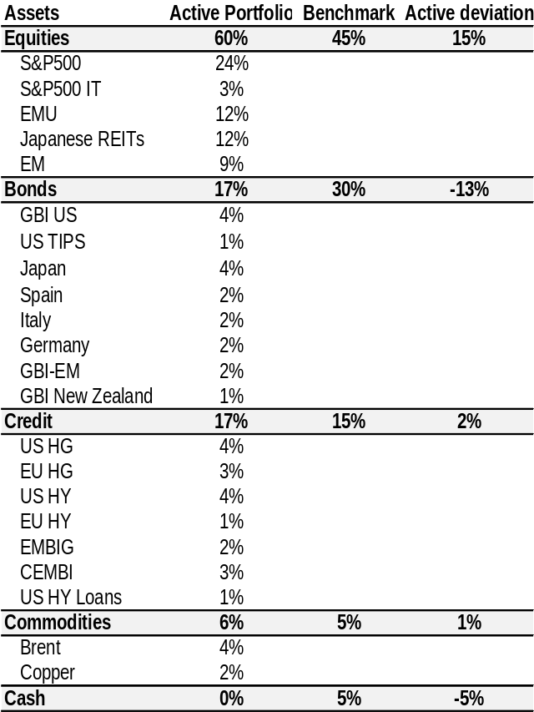
Source: J.P. Morgan

Long-short GMOS tactical exposures
The long-short GMOS model portfolio continues the tactical overlay exposures we have published here since 1995. They extend across bonds, currencies, credit, equities and commodities and are calibrated to a target Var, or tracking error, of 100bp of the overall size of an underlying global portfolio.
We reduce our overall tactical risk allocation below average (79 vs. 100) as rock-bottom volatility means the nominal sizes of our exposures would have to be way above average to reach our mean target VaR of 100, a dangerous strategy as it assures an investor has the biggest exposure right before a crash. Last month, we moved to assure that the lion’s share is in the positions we are most confident in and the types of trade that have been performing the best this year: equity outright long, and overweight yield and carry. This has worked and we made as much in June as we had made YTD until then.

GMOS Long-short portfolio exposures
VaR in bp, annualized.
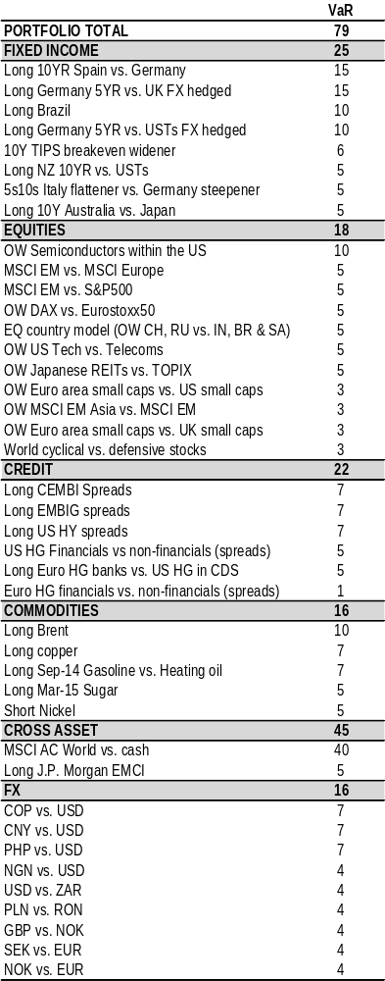
Source: J.P. Morgan
Our long in carry consists of FX carry through our overall EM FX index (JPM’s EMCI), CNY, COP and PHP; earning high roll yields in energy commodities; long EM local bonds (Brazil); higher-yielding credit (HY and EM); and long Euro periphery (Spain and Italy). We are now decently long EM vs DM in FX, credit, local bonds and equities. Our bearish view on UST duration is expressed only through its OW vs Euro duration.
Investors who held the recommended positions in the long-short portfolio from June 4 would have made 31bp since last GMOS on tactical risk of 100bp (1-sigma VaR, annualized). YTD, we are up 64bp, modestly below past years’ performance at the half-year mark. Returns came largely from being long equities, oil, EM and credit, and from the long-standing OW of euro vs. US and UK duration.
Performance (cumulative return, basis points)
 | since last GMOS (4 Jun) | YTD
Total | 31 | 64
Equities | 1 | -19
Bonds | 16 | 46
Credit | -2 | 44
Currency | -1 | -3
Commodity | 4 | -13
Cross-asset | 13 | 9
J.P. Morgan model portfolio performance
Quarterly performance*, bp, not annualized
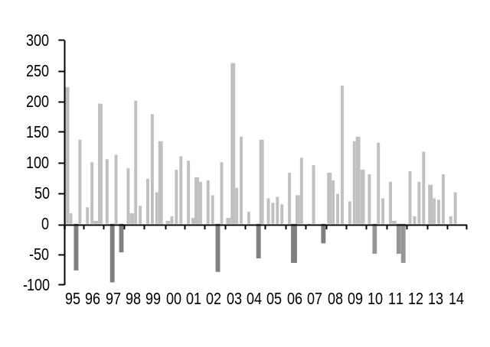
* The GMOS performance reported is calculated as of closing on the date of the GMOS publication. Any necessary adjustment for market movements today will be made in the following GMOS, reflected in the YTD GMOS performance section. Source: J.P. Morgan.

J.P. Morgan model portfolio performance by trade
P&L in basis points since the last GMOS publication date.
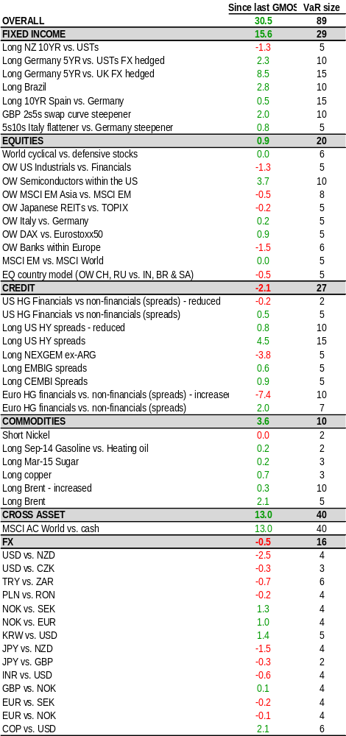
Source: J.P. Morgan

This Outlook was originally published as Global inflation’s bottoming – how should currencies respond? in FX Markets Weekly on June 27, 2014.

FX Strategy
- Another week, another trickle lower in volatility on below-average volumes. If anyone ever wondered how currencies might respond to the world’s major bond markets going Japanese sequentially, 2014 is providing a taster.
These Japan-like conditions will prove only a phase if inflation rises sufficiently, since below-target CPI sustains the G4 monetary policies partly responsible for such an unusual market environment.
In this sense, recent trends are potentially helpful: inflation is bottoming globally as well as in the majority of countries, and the (US) inflation theme is creeping increasingly into conversations.
This Outlook traces the FX implications of recent inflation developments. As a stand-alone variable, inflation has always been an inconsistent driver. What matters is the real rate environment resulting from the interaction between inflation and central bank policy.
- Real rate trends will diverge significantly across countries by year end. That’s another reason to think the dollar index and vols should become more interesting in Q4 but are not compelling now. In the interim, focus on much shorter-term inflation sensitivities, like sterling, Scandis and selective EMs.
Another week and another trickle lower in volatility on below-average volumes (Figure 1). In that context the dollar has slipped fractionally but continues to respect a year-long range roughly +/-2% around current levels of 84 on the J.P. Morgan index (JPMQUSD). If anyone ever wondered how currencies might respond to the world’s major bond markets going Japanese sequentially, 2014 is providing a taster. Of course a Japan-like environment – with zero policy rates, central bank asset purchases, low bond yields, low volatility and low turnover – will prove just a tedious phase if inflation rises sufficiently, since below-target CPI sustains the monetary policies partly responsible for such unusual market conditions. In this sense developments over the past few months on the price front are potentially helpful – CPI has bottomed globally, it is off its lows for the majority of countries, and it is beginning to reenter conversations (Figure 2).
Figure 1: Lower volatility and lower volumes reinforcing one other
J.P. Morgan VXY Global index of 3-mo implied volatility (%) versus CME FX futures volumes across all currencies (US$ bn)
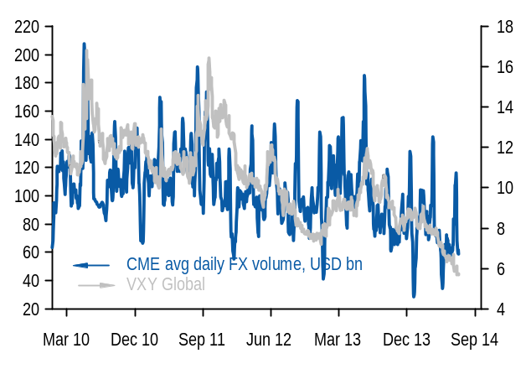 Source: J.P. Morgan
Figure 2: Inflation chatter is building with breakevens
US 10-yr inflation breakevens versus number of daily news stories containing the word “inflation”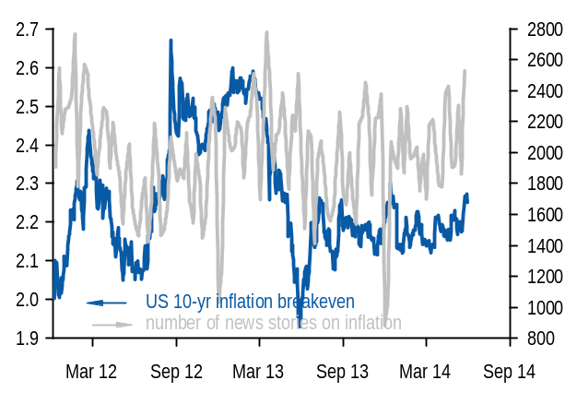Source: J.P. Morgan
Figure 3: Central bank balance sheet growth has meant more for global fixed income returns than for global CPI inflation
Aggregate growth in balance sheets of Fed, ECB, BoJ, BoE and SNB versus global CPI inflation and global fixed income returns (JPM GABI covering G10 gov’t bonds, EM local currency, US MBS and US/Euro investment grade credit). Year-on-year change for all series.
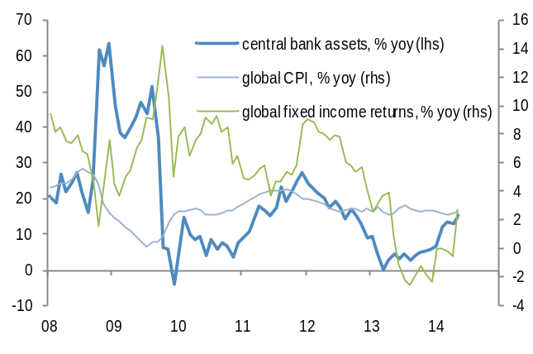
Source: J.P. Morgan
For currencies, inflation as a stand-alone variable has always been an inconsistent driver. What matters is the real rate environment resulting from the interaction between inflation and central bank policy. Since inflation’s impact is so market-specific, we trace out the pairwise implications. Real rate trends will diverge significantly across countries by year end. That’s another reason to think the dollar index and vols should become more interesting in Q4 but are not compelling now. In the interim, focus on much shorter-term inflation sensitivities, like sterling, Scandis and selective EMs.

Mild payback for balance sheet expansion
Ever since the major central banks began puffing up their balance sheets five years ago, there has been an underlying but fear that policymakers would overegg inflation. Indeed they have, but much more on the asset price side than on the CPI front. Whereas those markets closed to central bank purchases (fixed income broadly defined) have generated above-average returns for most of the QE era (the taper tantrum months were the exception), the prices of goods and services have remained in a below-average range of 0-2% (Figure 3).

Maybe the balance sheet paypack is still to come, but such a dynamic wasn’t part of the JPM forecast that three years of global disinflation would end this spring. Instead this forecast was based on more customary forces like a return to above-trend global growth and a turn in the commodity price cycle. Indeed those price pressures have come globally (up to 2.6% in May from 2.3% in January) and in the majority of countries. As shown in Figure 4, headline CPI is up in 13 of 20 countries this year, flat in one country (Mexico) but still falling in much of Europe (Euro area, UK, Poland, Hungary and Norway). Notably, core inflation is up in a few countries like the US, Canada and Brazil, highlighting that this spring’s move is probably not simply a transitory commodity price phenomenon.

There is no need to bolt for bullion or bitcoins just yet, however. A bottoming-out in inflation globally or in the US isn’t the same as an increase which is material enough to prompt central banks to shift policy this year in developed markets. This patience is mainly because wage inflation, which is the longer-term driver and therefore more of a policy focus, remains below-average throughout the major economies; indeed it is only nearing its long-term run rate in Norway (Figure 5). It is an honest admission that
Figure 4: Headline inflation is off its 2014 lows in 13 of 20 countries
CPI inflation – current (latest) reading, 2014 low and all-time low, %
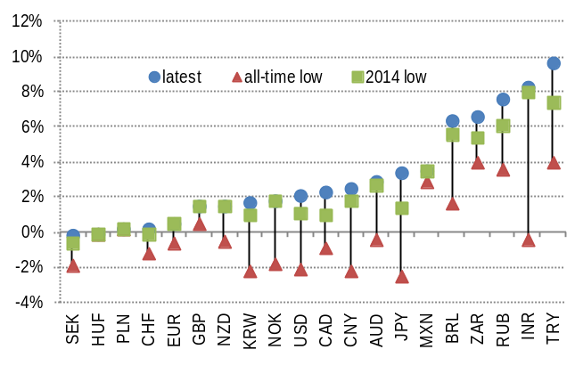Source: J.P. Morgan

Figure 5: Wage growth is closest to average in Norway and furthest from average in UK
Wage inflation (preferred measure of JPM economists for each country) currently and versus the high, low and average of the past 20 years
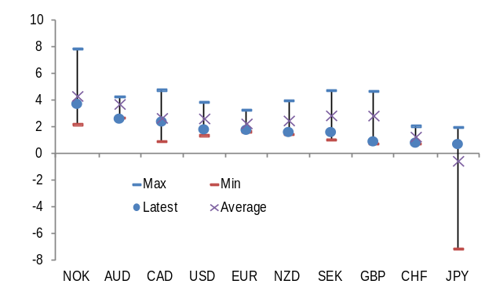
Source: J.P. Morgan

neither we nor central banks have much confidence in predicting when and by how much wages will respond to falling unemployment, since the relationship between measures of slack (like unemployment) and wages is variable over time, and since the degree of slack in key countries like the US and UK is quite debatable. Despite an inconclusive debate over slack, most investors think the risk bias around inflation is higher from current levels. That is why long-term inflation breakevens haven’t declined much from their long-term averages, even in the Euro area. This bias plus valuations motivate the tactical longs in inflation markets recommended by JPM’s Rates Strategy team.

FX and inflation: the general case
For currencies, inflation as a stand-alone variable isn’t inherently good or bad, despite the purchasing power parity claim that the currencies of higher-inflation countries depreciate over time. That proposition holds for many currencies over very long (multi-year) horizons, but not over more investable ones like a few months or a couple of years. Over these shorter horizons, central bank behaviour around inflation is more important, since together, policy expectations plus inflation expectations determine real interest rates, which are a consistent determinant of currency performance. Figures 6 and 7 illustrate the point: the dollar index has only a loose, negative correlation with inflation expectations (R² of 0.19) but a much higher and positive correlation with real rates (R² of 0.61).

FX and inflation: the specific cases
Most would accept that real rates matter; the harder part is judging the path of real rates over the next several months, since it depends on how central banks decide to set policy. USD is hardest to judge in this respect. The Fed seems committed to another year of zero policy rates while inflation is turning up (implying falling real yields and USD weakness), but the front end of the US bond market is so mispriced versus the Fed dots (about 75bp for December 2016) that rising inflation could trigger a sharp repricing when wages turn (implying rising real rates and USD strength). We are fairly confident that repricing will occur by year end but have less confidence in the short-term path. For trades, this implies a couple of short USD trades for the summer (USD/CNY, USD/PHP) while also owning some protection through dollar-based vols which would rally on higher front-end rates (USD/CHF, AUD/USD).
Like the US, the real rate story around JPY is also tricky. Our sense is that Japanese inflation is peaking, which means Japanese real rates are troughing. All else equal, this development is yen-positive, particularly if the always-inevitable rise in US real yields fails to occur. So in line with a low-confidence USD index view this summer, USD/JPY’s direction is also tougher near term (target 102) but higher conviction by year-end (target 106). The shocker would come if, instead of peaking, Japanese inflation continued to rise such that it prompted a BoJ version of taper talk. That event would be quite yen-positive due to a yield spike well in excess of inflation; it also seems low-odds this year.
Figure 6: USD index shows only a weak correlation with inflation expectations
J.P. Morgan nominal effective USD index regressed on inflation expectations from 10-yr TIPS. Sample is from 1997 to present.
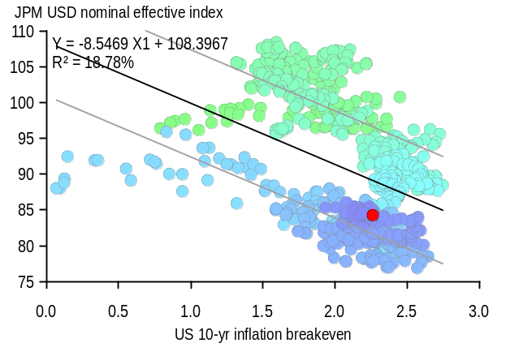
Source: J.P. Morgan

Figure 7: Much more of USD's variation is explained by real yields
J.P. Morgan nominal effective USD index regressed on real yields from 10-yr TIPS. Sample is from 1997 to present.
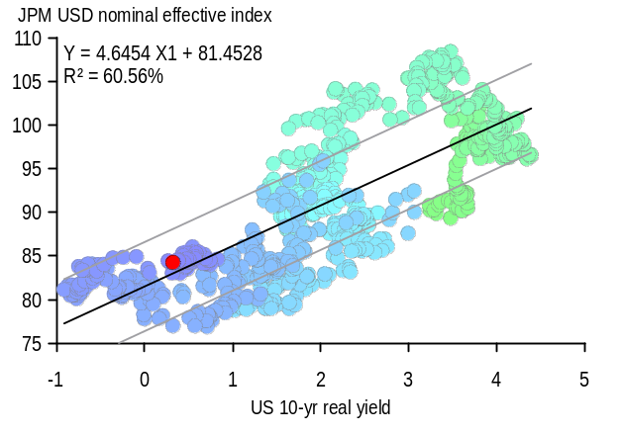Source: J.P. Morgan
The real rate paths for GBP, EUR and the Scandi’s look clearer. Falling UK inflation near-term but a relatively anxious Bank of England is lifting real rates currently (GBP-positive). Our bias is to think real rates edge slightly higher into year-end even as inflation returns to 2% in early 2015, since the sterling curve discounts too slow a pace of rate normalisation (a cash rate of about 2.5% by end-2018). EUR’s real rate path should be close-to-unchanged from current levels for the rest of the year since ECB policy anchors the short end while inflation bottoms around 0.3% this summer and rises to about 0.7% by December. The real rate divergence informs both the year-end EUR/USD and EUR/GBP forecasts (EUR/USD 1.30, EUR/GBP 0.78), though the EUR/GBP forecast is higher-conviction given

the Fed cross-currents noted above. NOK’s real rates will probably edge slightly lower since inflation should trough soon while rates remain on hold until 2016. SEK’s could move lower, mainly due to the possibility of at least one more rate cut in the context of deflation (so nominal rates fall more than inflation slips). Viewed collectively, these inflation trends in Europe support a tactical long in GBP/NOK.
The paths for benchmark EM currencies are mixed. For BRL, rising inflation and a central bank on hold might normally look currency-negative, but the central bank’s focus on currency stability though its swap program provides a counterweight. USD/BRL probably moves in a 2.20-2.25 range this summer. For TRY, inflation is probably peaking but that advent is unlikely to be currency-supportive given the CBRTs easing cycle. South African inflation is peaking too and the SARB should hike once more – all positive for real rates but from too low a starting level for a country with such a large external imbalance. Avoid ZAR. For further details see today’s Emerging Markets Compass, or a summary of its FX recommendations on page 16 of this week’s FX Markets Weekly in the section Emerging Markets FX.

Trades
- Sell NOK and SEK vs. EUR in cash
The expectation is for the Riksbank to not only cut its target rate by 25bp but also to strike a very dovish tone by slashing forward rate expectations, which should be bearish for SEK. Given that the Norges Bank is putting a very high weight on rates in Sweden and Euro area (a decline in these contributed to nearly half of the decline NB’s rate forecasts in its latest meeting), we expect NOK and SEK correlations to increase. Indeed, 1m realized correlation between EUR/NOK and EUR/SEK has already increased to 65% (by contrast, implied correlation is yet to catch up and is still at 48.5%; Figure 8). Thus we recommend adding long exposure to both EUR/NOK and EUR/SEK in cash.
- Buy EUR/NOK in cash at 8.377 with stop at 8.258.
- Buy EUR/SEK in cash at 9.194 with stop at 9.058.
- Add longs in GBP vs. NOK
As noted above, GBP appears cheap on most crosses based on our short term fair value models. Given Carney’s recent commentary and relatively benign recommendations from FPC to cool housing, we think that there is room for GBP to strengthen further. Moreover, while the latest BoP report showed that the current account balance stayed at record lows of -4.5% of GDP (on a 1-year rolling basis), other details were stronger with the basic balance getting a boost from FDI
Figure 8: Implied correlations between EUR/NOK and EUR/SEK are too low relative to the realized
1m realized vs. implied correlation between EUR/NOK and EUR/SEK; %
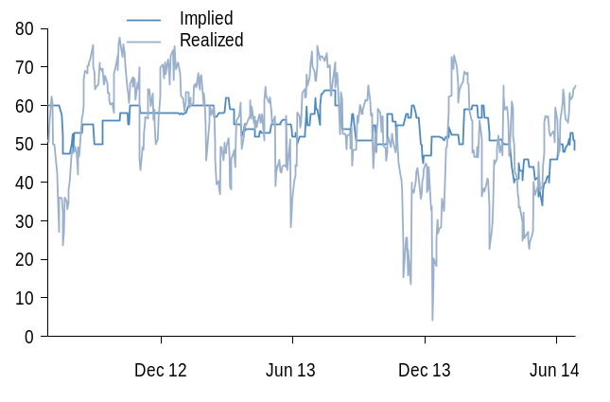
Source: J.P. Morgan
(thanks to a large M&A deal in Q1). We prefer initiating GBP longs vs. NOK for the reasons discussed in the prior bullet.
- Buy GBP/NOK in cash at 10.457. Stop at 10.205.
- Buy PLN/RON in cash
Political risks in Poland that contributed to PLN underperformance are diminishing after this week’s parliamentary confidence vote, as are the balance of payments risks with less concern on outflows from the country given ECB’s dovish stance. Meanwhile, activity data in Romania is likely to slow moderately (specifically IP and exports) and inflation has been low, reinforcing our view that the central bank is intervening, and will continue to intervene to weaken the currency (see Emerging Markets for more details).
- Buy PLN/RON in cash at 1.057. Stop at 1.035.
- Stay short 3-mo USD/PHP NDF
We stay short USD/PHP in anticipation of more hawkish direction of policy by the BSP. We continue to look for the BSP to be preemptive against inflation, and this macro story has not changed given the relatively sparse data calendar this week.
- Stay short 3-mo USD/PHP NDF at 43.850 on June 20. Marked at +0.1%.
- Stay short USD/CNY through a 3-m NDF
USD/CNY fixings stayed relatively stable this week and remained supportive of this carry trade which continues to screen attractive from a risk-adjusted standpoint.
- Sold a 3-mo USD/CNY NDF at 6.199 on June 6. Marked at 0.35%.
- Short NZD vs. USD via options expired
Last week we held the 1-mo bearish NZD/USD risk reversal as there was only one week to expiry and we thought there was a decent chance that the call expires out of the money, which would limit losses on the trade to the premium we paid. Unfortunately, the rally in Treasuries and the commensurate weakening in the USD led to the call option being exercised which yielded us a loss.
- Bought a 1-mo 0.835 NZD/USD put vs. a 0.8700 call on 27 May for 12.5bp. Options expired this week for a P&L of -82bp.
- Hold a bearish cable one-touch calendar spread
This trade was intended as a way to position for a rise in volatility in the lead-up to the Scottish referendum on September 18. Forward volatility has indeed risen but this effect has been overshadowed by rally in spot, hence the trade’s value has halved. We recommend holding on to this trade for now.
- Sold a 2-mo/buy a 4-mo 1.63 GBP/USD digital put at net cost of 21%. Now worth 8.5%.
- Hold 1Y ATMF EUR/CHF put
The ECB will continue to strike a dovish tone next week and overall, we continue to expect EUR/CHF to drift towards 1.21 in the next few quarters, a level at which implied vols should invert higher. As a result, we hold exposure to this trade.
- Bought a 1Y ATMF EUR/CHF put (strike 1.2088) for 1.81% on March 14. Marked at 91bp.

J.P. Morgan FX Forecasts vs. Forwards & Consensus
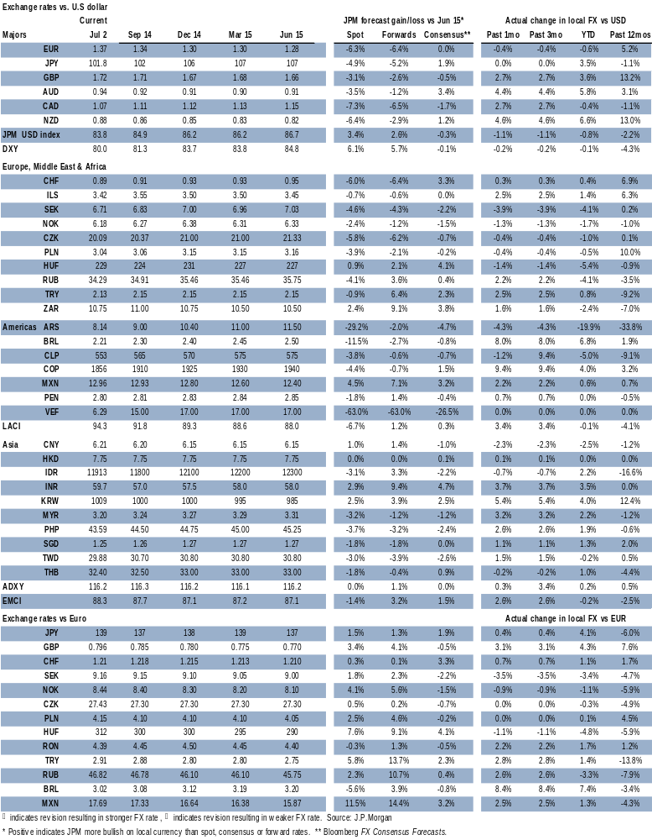

Fixed Income Strategy
- Remain OW Euro area duration vs. UK and US duration on continued policy divergence.
- We expect Euro area growth to accelerate to 2% in H2, and we see the ECB’s TLTROs as supportive of periphery bond markets: keep periphery spread narrowers.
- Hold OW Brazil local bonds due to strong investor demand dynamics and disappointing growth.
- Open US TIPS breakeven widener on a macro backdrop that is supportive of higher inflation expectations and inflation risk premia.
- We update on our systematic cross-market signals, where our real yield signal points to OW Australia vs. Japan.
- Remain OW 10Y New Zealand government bonds vs. US Treasuries.
Yield curves flattened across the US, UK and Euro area over the month (Figure 1), with a combination of macroeconomic and policy developments an important driver internationally.
In the US, the “pot hole” of 1Q got deeper, with the latest official data showing a contraction of 2.9% (qoq annualized) in GDP (Table 1). How should we think about this disappointingly weak quarter? We think it was primarily due to a combination of negative factors that are mostly one-off in nature - including a sharp inventory drawdown after a rapid buildup in 2H13, expiration of extended unemployment benefits, weather affecting consumption, and volatility in investment (Just a bit on the outside, Michael Feroli, Jun 25). Going forward, the survey data for 2Q suggest growth is tracking our 3% forecast, though with some downside risk arising from the latest consumption data.
The day after our previous GMOS was published, the ECB, prompted by continued downside surprises in inflation relative to its forecast, delivered a larger than expected package of measures. In particular, the fixed rate Targeted LTROs were larger in size, with an initial allowance of €400bn and a further allowance that could be as large as €450bn if Euro area banks were simply to keep their lending to the real economy unchanged over the next two years. Additionally, there are no penalties for failing to meet lending targets, beyond banks having to repay TLTRO borrowings in September 2016 instead of September 2018.
Figure 1: Changes in G4 benchmark yields on the month
%,
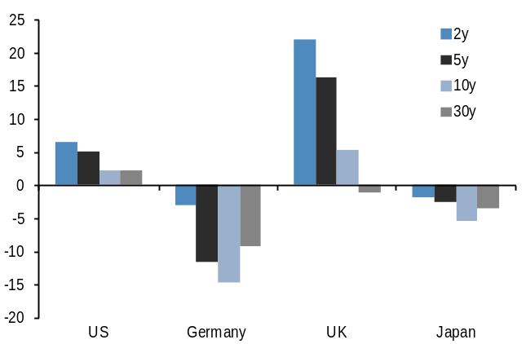
Source: Bloomberg
Table 1: JPM GDP growth forecasts for 2014 now vs. at end-2013
%, qoq annualized
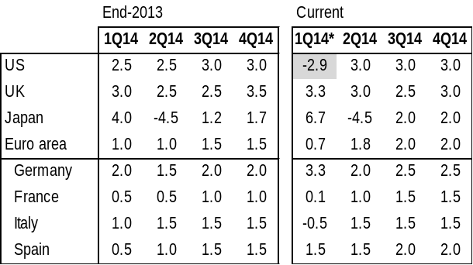
* 1Q14 in the current column are latest available estimates.
Source: J.P. Morgan
This should reinforce the easing in Euro area financial conditions. But given our estimate of the output gap, even with faster growth we expect the ECB to continue to be disappointed on inflation (ECB tilts Euro area growth risks to the upside, David Mackie et al, Jun 13).
The combination of an improvement in the macro outlook and a dovish ECB in H1 has supported our medium-term expectation of narrower spreads of periphery government bonds to German Bunds. We think these drivers will remain in place with the ECB’s TLTROs supporting periphery bond markets via demand for carry. Our European rates colleagues now forecast Italian and Spanish 10Y yield spreads to Germany to narrow to 110bp by the end of the year (vs. forwards of 163bp and 153bp respectively). That said, we see reasons to be cautious as the current low volatility environment has the potential to encourage complacency the longer it continues, and our European Client Survey (Jun 26) shows investors are fairly long the periphery and have been for some time. At the same time, any sign of sovereign QE by the ECB would add impetus to periphery spread compression. We keep our long-standing OW periphery vs. core position.
In the UK, the last few weeks have seen monetary policy take centre stage, with an apparent lack of consistency in communications. Last month, the BoE struck a more dovish than expected tone in the May Inflation Report, seemingly leaning against expectations that it might raise rates sooner, only for Governor Carney to use the annual Mansion House speech this month to describe the decision on rates as “becoming more balanced” and that the first hike in rates “could happen sooner than markets expect”, prompting a sharp rise in front-end yields. Subsequently, it has become clear that the MPC view on the evolution of the policy rate is highly data dependent (MPC’s TSC appearance echoes sentiments of June minutes, Allan Monks, Jun 24), which in our view will intensify the market focus on labor market data. Our economists continue to expect the first rate hike in Q1 15, with some risks for an earlier rise.
The increasing divergence between an ECB with an easing bias and a Fed and BoE approaching the beginning of policy rate normalization has contributed to spreads between 5Y German bunds and US Treasuries/UK gilts to widen to their highest level since 2006 and 2005, respectively. While this has prompted questions about how much further these spreads can widen, we continue to see upside. In particular, while the market now broadly prices in our view of the expected timing of a first rate hike by the Fed and the BoE (Figure 2), there is still a gap between market pricing in terms of the pace of hikes. For example, Figure 3 shows that OIS forward rates continue to imply a substantially lower Fed funds rate in future years than the Fed’s own projections. We stay long 5Y German Bunds vs. US Treasuries and UK gilts.
The environment of low volatility and range-bound Treasuries has continued to support EM local market bonds, which have outperformed DM bonds by around 0.3% on an FX-hedged basis since our last publication. Additionally, EM fixed income has been supported by increasing inflows to EM local currency funds, and the shift to more monetary easing in many EM countries should help to attract further inflows into these funds. The key risk to watch for EM relate to any unexpected developments in Iraq and potential impact on oil prices. Within EM, we stay OW Brazil local debt on an FX-hedged basis. The market has absorbed heavy supply in recent months without materially affecting bond prices, which was one risk to this trade our EM strategists highlighted earlier in the year. And on the growth front, the output gap appears to be moving towards the disinflationary camp, which should be supportive of bonds (see EM Local Market Compass, Jun 27).
Figure 2: Market-implied timing of a first rise in interest rates vs. JPM economist forecasts
Solid lines show the market-implied timing of a first rise in policy rates derived from the OIS curve*; diamonds show the beginning of the quarter when J.P. Morgan economists forecast a first rate hike
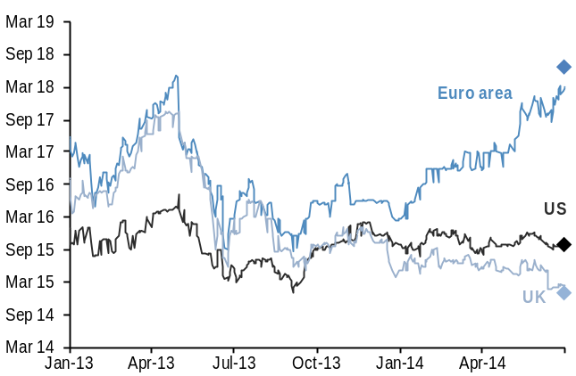
* Time at which the 1M OIS rate is 25bp above current policy rates after adjusting for term premia. We assume 5bp, 10bp and 5bp per year for the US, UK and Euro area respectively, rising linearly.
Source: J.P. Morgan
Figure 3: FOMC Fed funds target forecasts vs. OIS rates
Trimmed mean* of FOMC year-end Fed funds target forecasts for 2015 and 2016 vs. 1-month OIS rates out of Dec 15 start date; %
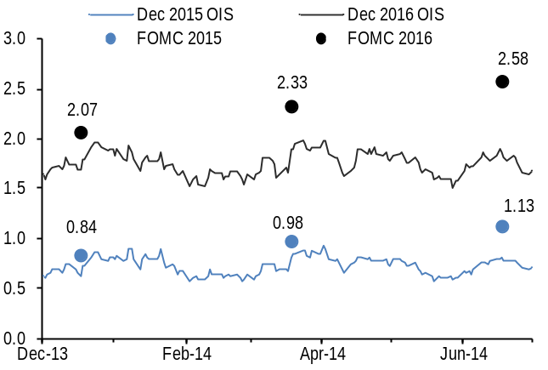
* Excludes the 3 highest and lowest projections in the Summary of Economic Projections.
Source: Federal Reserve, J.P. Morgan

Systematic trading signals
We update our suite of systematic signals for outright and cross-market fixed income trading to complement our qualitative and discretionary approaches. Our duration model uses signals for momentum in prices (from both equity and bond markets), economic news (via manufacturing PMIs and earnings revisions) and carry (via the curve slope), and we apply these signals to bond futures in 10Y US, German, Japanese, UK, Australian, Canadian, Swedish and Swiss government bonds. The duration model
Table 2: Current positioning of systematic duration signals
Positive numbers indicate long duration, negative numbers short duration
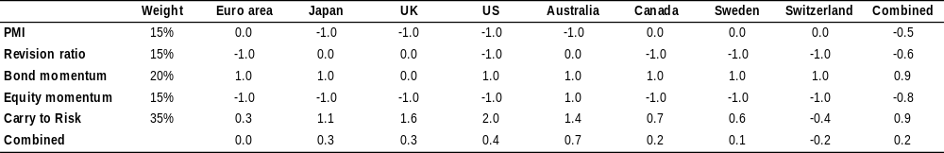

Source: J.P. Morgan
argues for small long duration position overall (Table 2), and the performance of the combined signal across countries has been flat year-to-date (Table 3).
We also monitor a range of cross-market signals which we have found useful in cross-market allocation, and apply these to 10Y interest rate swaps in major developed markets. These include 1) carry, 2) the change in the curve slope (capturing the tendency of markets which have underperformed recently to catch up), 3) real yield (the 10Y nominal yield less Consensus forecasts for inflation over the next 10 years), and 4) unemployment relative to the average over the previous 10 months. Some of these cross-market signals have performed better so far this year (Table 4), particularly the real yield and unemployment signals. We focus on the real yield signal (Table 5), which points to an overweight in Australia vs. Japan with a real yield differential of around 2.3%.
Table 3: Performance of duration signals
Duration signals across all 8 countries for each signal*, % change in the cumulative total return index for each signal.
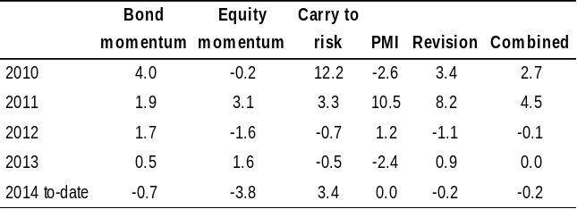
Equally weighted average across the eight countries (Germany, Japan, UK, US, Australia, Canada, Sweden and Switzerland) for each signal, and the combined performance using weights in Table y.
Source: J.P. Morgan

Table 4: Performance of cross-market signals
Cross-market signals using two long-short pairs for each signal*, % change in the cumulative total return index for each signal.
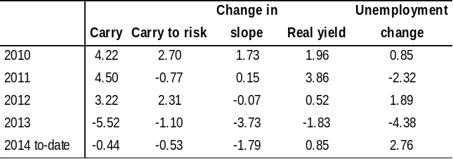
For each signal, the eight markets (Euro area, Japan, UK, US, Australia, Canada, Sweden and Switzerland) are ranked at the end of each month. The top market is paired against the bottom market, and the second with the second-to-last.
Source: J.P. Morgan
Table 5: Cross-market signals
%. For each signal, the most favored country is shown in grey, and the least favored in white.
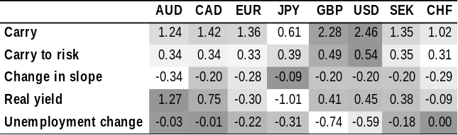
Source: J.P. Morgan

Long-short bond portfolio
- Stay long 5Y German bunds vs. UK gilts () and USTs (), FX hedged
We retain our long-standing view of wider yield spreads between German Bunds and UST's/UK gilts. Our European rates strategists project 5Y US-Germany spread of 200bp by end-2014 and a 5Y UK-Germany spread of 205bp.
- Remain long Spain vs. Germany in 10 years (), and hold 5s10s Italy flattener vs. Germany steepener ()
As noted above, we retain our medium-term view for narrower spreads between periphery and core government bond yields.
- Stay long 10Y NZ bonds vs. US Treasuries, FX hedged ()
We think the combination of an interest rate rise by the RBNZ and a more hawkish statement in its June meeting, even as it revised its inflation forecast lower, signals an intent to pursue more aggressive rate hikes in the near term. Further hikes, together with already tightening financial conditions and an elevated currency are supportive of the long end of the NZD curve as this has a dampening effect on economic activity, which should weigh on long-term yields (see also Australia and New Zealand, GFIMS, Jun 13).
- Hold long in Brazil, FX-hedged ()
As we note above, the market has absorbed a heavy supply in recent months, and the output gap appears to be moving towards the disinflationary camp, which should be supportive of bonds (see EM Local Market Compass, Jun 27).
- Open 10Y US TIPS breakeven widener ()
Given the recent acceleration in inflation, we look for headline CPI to reach 2.4% by year-end. However, we expect the Fed to maintain a dovish tone as we see core inflation remaining muted and 5Yx5Y breakeven inflation rates remaining low. This macro backdrop argues for higher inflation expectations and inflation risk premia (for further detail see TIPS, USFIMS, Jun 27). In addition, given the combination of disappointing 1Q US GDP growth and the decline in unemployment has raised concerns that potential growth in the may be lower, we see this as a risk bias tilted toward further inflationary pressures.
- Open long Australia vs. Japan in 10Y,
FX-hedged ()
As indicated above, the real yield signal from our cross-country systematic signals points to a long position in Australia vs. Japan with a real yield differential of around 2.3%.
- Closed 2s5s GBP swap curve steepener
We took profit on our 2s5s GBP swap curve steepener following BoE Governor Carney’s Mansion House speech, as the more hawkish rhetoric posed risks of faster rises in short-term yields (see JP Morgan View, Jun 13).

Long-only bond portfolio
Our long-only bond portfolio complements our longstanding portfolio of long-short trades. We take as our starting point a benchmark of $29tr of government and government-like bonds, comprising conventional government bonds, index-linked bonds and MBS. We construct a global bond portfolio using a small number of bond sectors, which takes this benchmark as its baseline, but is tilted to reflect the tactical themes discussed above.
Recommended portfolio holdings
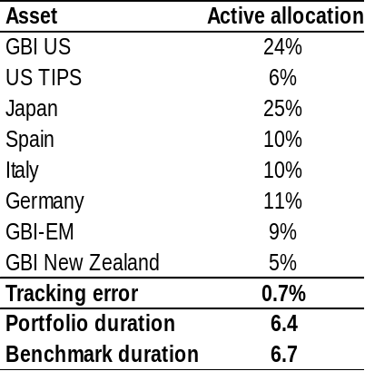
Source: J.P. Morgan
Our long-only portfolio holds overweight in the Euro area periphery, Japan, US TIPS, EM and New Zealand, and an underweight US Treasuries and the UK. Duration is around 3 months below benchmark, and the tracking error declined to 0.7%. Last month, our recommended portfolio was broadly flat relative to the benchmark.

Credit Strategy
- Credit spreads are close to pre-crisis lows, issuers are starting to leverage up and credit is likely the relatively more over-owned asset class. We have reduced our OW further.
Within credit, we maintain our focus on US HY and EM credit markets.
A more advanced credit cycle in the US and deleveraging in Europe mean we go long European HG vs. US HG.
We stay OW financials vs. non financials in both Europe and the US, but close the long in NEXGEM ex-Argentina.
We further reduced our credit OW intra-month to small (2% from 5%) on the fast growth of the asset class, tight spreads, stronger M&A activity, and concerns about liquidity during the eventual rise of interest rates (J.P. Morgan View, Jun 13). Credit is the faster growing risk asset class, and thus relatively more over-owned by end investors. Spreads have fallen to levels not far from past cycle lows. These lows typically happen about 2/3rds into an expansion, which is where we think we currently are. Issuers are starting to lever up, and investors are beginning to worry about how the eventual exit from the credit trade will fare in a world of reduced market making by banks.

The relationship between equity and credit is not linear. In a bullish risk environment, equity markets can continue rising while credit spreads will benefit less and less, as companies tend to start re-levering later in the cycle. However, should we see a sell-off in risk due to earlier or greater than expected Fed rate hikes, both equities and credit would likely suffer, but credit is far less liquid. As such, we prefer to take more risk in equities.

Within credit, we continue to focus on US HY and emerging markets and we now add a European HG OW vs. US HG. Deleveraging and ECB support to the European banking sector should continue to tighten bank credit spreads, which are a significant part of the European market. Secondly, the US credit cycle is more advanced than in Europe and will likely see companies re-leveraging in the US vs. deleveraging in Europe, particularly for banks. We recommend implementing this trade via selling protection in iTraxx Senior Financials and buying protection on CDIX.IG (Credit Trade Opportunities, Dulake et al., Jun 26).

Figure 1: Euro HY yields vs. Eurostoxx50 dividend yield
%. iboxx Euro HY yield-to-worst and Eurostoxx50 the next year’s expected dividend yield from Bloomberg 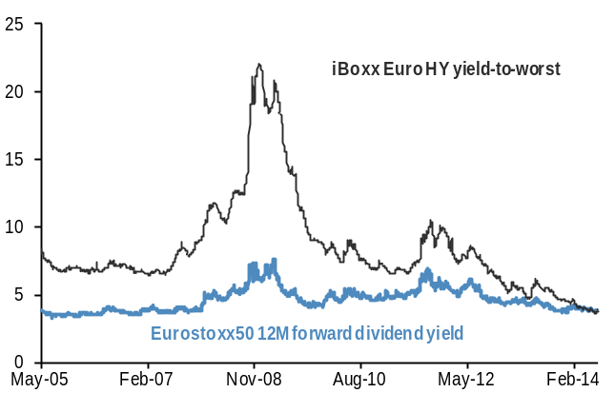
Source: Bloomberg, iBoxx, J.P. Morgan.
We stay long US HY spreads but took profit on our long Euro HY spread position at the beginning of June as credit metrics were worsening and yields had reached very low levels. Since then, Euro HY spreads are 2bp wider, while US HY is 11bp tighter. Next year’s expected dividend yield on the Eurostoxx50 is now above the Euro HY yield-to-worst for the first time since we have data in 2004 (Figure 1). Additionally, with spreads and yields so low, equities likely have significantly more upside in terms of capital appreciation than credit (European High Yield Market Update and Commentary, Matthew Bailey et al.)

In Europe, financials have underperformed non-financials significantly over the past month on position squaring following the ECB’s TLTRO announcement and the growing risk of widening fines on European banks. We still like European financials, given they are continuing to delever while non-financial credit metrics are worsening but we trim our OW. In EM, we maintain our long EMBIG and CEMBI spread trades but we close our long in NEXGEM ex-Argentina at a loss.

Our US HG strategists have added an additional framework for evaluating the credit fundamentals of HG issuers which takes into account the changing composition of the US HG market over time. For key metrics such as leverage and interest coverage there has been a deterioration over the past few years for individual issuers, but the composition of the market has changed such that this is mostly offset at the index level. Comparing these metrics to spreads shows that spreads have tightened while leverage has risen modestly, but the trend in interest coverage is supportive of the tighter spreads (CMOS, Beinstein et al., Jun 27).

Figure 2: EM spread over US HG
Basis points, adjusted for differences in maturity, sector and rating 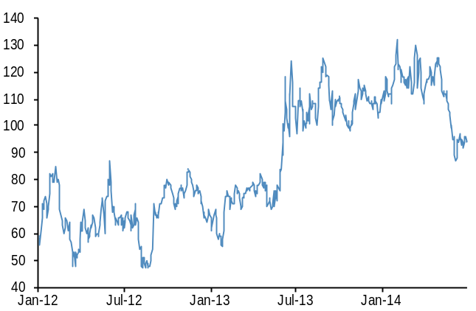
Source: J.P. Morgan EM corporate research (EM vs. US HG Relative Value Report, Eric Beinstein and YM Hong)

Figure 3: US HG credit spreads
Bp. JULI index.
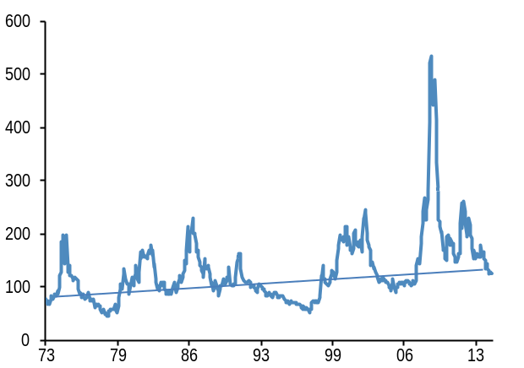
Source: J.P. Morgan, Barclays
Figure 4: US HY credit spreads
Bp. Grey area is the default rate.
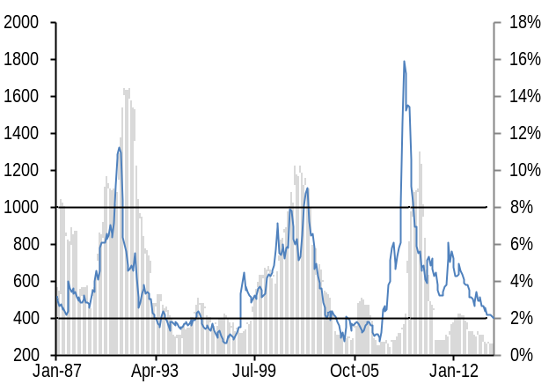
Source: J.P. Morgan, Barclays

Long-short credit portfolio
- Long US HY spreads ()
High-yield spreads remain elevated vs. default rates, which have now fallen below 1%. US HY spreads are also still around 100bp above the lows seen in the last two expansions and we expect them to tighten further.
- Long EMBIG and CEMBI spreads ()
Event risk in EM appears to be fading for now, while low volatility and the search for yield are supporting carry trades. Improving economic data in China are also helping.
- Sell protection on iTraxx senior financials vs. buy protection on CDX.IG ()
A more advanced credit cycle in the US and deleveraging in Europe mean we go long European HG vs. US HG. European banks should benefit from ECB support and are still in delevering mode. Thus we expect financials to outperform.

- Long US and EU HG FINs vs. non-FINs in spreads ()
Banks remain in delevering mode, especially in Europe, while non-financials are seeing leverage increase somewhat as they issue debt to buy back their own stock. In Europe, the ECB measure, coupled with continued strong demand for quality spread product, make us OW financials.

- Close Long NEXGEM ex-Argentina ()
NEXGEM underperformed again last month, even excluding Argentina. The index trades on a number of idiosyncratic events in the constituent countries and we now close the trade at a loss.

Long-only credit portfolio
This section presents the long-only version of our credit portfolio. We define a market-capitalization weighted global credit benchmark (hedged into USD), using the most representative ETF on each sector to track total returns. We weight each component in the active portfolio, according to our expectations of relative returns and risks over the coming months. Table 1 shows our active allocations as well as the portfolio’s yield, rating and duration
This month we maintain our OW in US HY and emerging markets given more attractive spreads than in high grade. We also now move overweight European vs. US HG on A more advanced credit cycle in the US and deleveraging in Europe. This positioning generates a tracking error of 1.3% based on daily returns over the past 6 months, and a yield 0.9% above the benchmark with a third of a year shorter duration. The average rating for our portfolio, which takes into account our active positions, and is based on Moody’s and S&P’s fund ratings, is currently BB rated, one notch below the benchmark.
Table 1: The long-only global credit portfolio
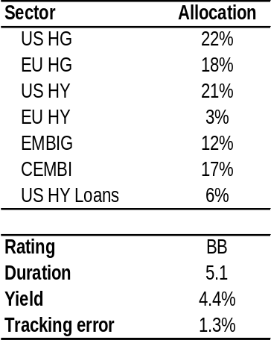
Source: J.P. Morgan

Equity Strategy
- We add risk to our OW in EM equities but focus the short leg on the US and Europe only.
- Recent momentum in Japanese equities and the prospect of further government policy action make an implicit Japanese equity underweight unattractive, in our view.
- Take profit on peripheral Euro area equities and Euro area banks as valuations no longer look attractive and litigation risks remain elevated.
- Open OW DAX vs. Eurostoxx 50. DAX is trading with the lowest P/E multiple across Euro area countries and the rebound in EM and China implies greater upside for German equities.
- Open a long in Euro area small caps vs. their US and UK counterparts.
- Our systematic global equity country model currently favors China, Sweden, and Russia vs. Switzerland, Brazil, and South Africa.
- Stay OW US Semiconductors into H2 as we remain constructive on medium-term fundamentals.
- We OW Technology vs. Telecoms based on 11-month relative return momentum across US sectors.
- Stay OW Cyclical vs. Defensive sectors globally on positive momentum in the global manufacturing PMI.
Global equity markets continued to rally over the past month, with the MSCI AC World index printing new historical highs. In a stark contrast to earlier this year, Japan has been the best performing region this month, up by almost 7%, reversing most of its previous loss since the beginning of the year. The S&P 500 is up almost 3%, MSCI EM is up by 2% whilst Eurostoxx 50 remained flat. EM equities outperformed by almost 1% against DM equities over the past month but admittedly momentum has faded over the past three months (Figure 1). We remain positive on EM vs. DM into the second half of the year due to cheap valuations, further compression of excessive risk premia in EM, further covering of EM underweights by global funds, an economic growth improvement into H2 and an acceleration of EPS growth into 2015.
The recent momentum in the Japanese equity market is encouraging, especially coupled with renewed government policy activism. Our strategists note that the credit cycle will be a necessary part of turning the current upswing into
Figure 1: MSCI EM flat vs. MSCI World YTD
Ratio of MSCI EM (MXEF) vs. MSCI World (MXWO) 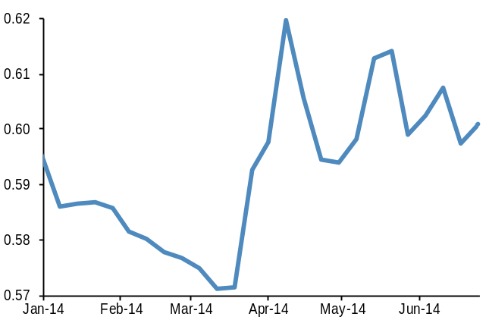
Source: Bloomberg, Datastream, J.P. Morgan

Figure 2: EPS growth across regions
YoY change in 12m forward EPS projections by IBES analysts
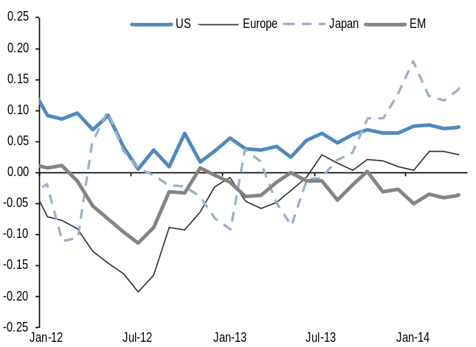
Source: Datastream, J.P. Morgan
a sustained bull market for Japan. Although the real estate market is bottoming and inflation expectations are rising, encouraging a shift to debt financing, domestic investors remain elusive participants, which keeps us a little wary (Japan equity research, J. Koll et. al, Jun 23). We are not yet re-introducing our previous Japanese equity overweight but we prefer to express our MSCI EM equity overweight vs. an equally weighted basket of S&P500 and MSCI Europe rather than MSCI World. In this way we remove an implicit underweight on Japanese equities.

Long-Short Equity Portfolio
- OW MSCI EM vs. S&P500 and MSCI Europe ()
We maintain our preference for EM vs. DM equities for the reasons mentioned above. But we prefer to focus the short leg on the US and Europe rather than MSCI World as the recent momentum in Japanese equities and the prospect of further government policy actions make an implicit Japanese equity underweight rather unattractive.
- OW J-REITs (TSEREIT) vs. TOPIX ()
REITs have outperformed the TOPIX YTD but this trade has lost some momentum recently. We still maintain our preference for REITs on further upside to a rise in rents this year. Low JGB yields have been supporting strong sales and hence REIT prices. Given that our analysts expect reflation in real estate in Japan this year, this should benefit JREITs in H2.
- Keep OW in MSCI EM Asia within EM but reduce ()
Asia continues to be the region where we have the highest conviction over the medium term within EM as continued economic, policy and political uncertainty do not bode well for the EMEA or Latam regions, in our view. The Chinese manufacturing PMI increased to 51 in June, a fourth consecutive increase, which should support Chinese and Asian equities more broadly. Further, our EM strategists expect that, as Asian growth accelerates, EPS should follow and the 1H14 compression in risk premiums would continue. A risk for this trade is a further spike in oil prices given that Asian countries are predominantly oil importers. As a result we reduce the size of this trade for the near term.
- Take profit on OW in Italy vs. Germany and shift to OW DAX vs. SX5E ()
We closed our OW in peripheral vs. core euro area equities (i.e. Italy vs. Germany, see J.P. Morgan View, Jun 20th) on the basis of the loss in momentum coupled with overstretched valuations. We believe that the risk reward for DAX has improved and now recommend going long DAX relative to Eurostoxx50. Not only have DAX earnings revisions turned positive, the index is now trading at amongst the lowest P/E multiples across the Euro area countries. The DAX is also a global cycle play with 57% of the market cap weight in cyclical sectors on which we are bullish. And it is more exposed to a pick up in activity in EM where we are more positive. A decline of the euro to 1.30EUR/USD by year-end, as projected by our FX strategists, should help export biased DAX companies (see Mislav Matejka and team).
- Open long Euro area (MSCI EMU Small cap) vs. US (RTY) and UK (FTSE 250) small caps ()
We see more value in small caps in the Euro area than in the US or the UK. SMid-Caps in the US and the UK are now trading at peak multiples. Euro area SMid-Caps are trading on an average P/B multiple of 2.32x vs. 3.60x of their US and 3.03x of their UK peers. In comparison, the historical peak multiple was 2.95x for EMU and 3.26x and 3.19x for the US and the UK, respectively. This indicates UK/US Smids are trading at a premium to their Euro area counterparts.
- Further, our European equity strategists are underweight UK equities based on a more defensive weight of the index as well as a high correlation with commodities.
- Using momentum to trade US equity sectors. OW US Technology against Telecom ()
A momentum strategy on US equity sectors, which OW the sector with the highest return and UW the sector with the lowest return over the past 11 months, is currently favoring US Technology vs. Telecom. This sector momentum strategy has been flat YTD.
- Close OW Banks within the Euro area
Our OW in euro area banks via SX7E vs. SX5E suffered over the past month with news of bank litigation. Given uncertainty regarding further litigation against European banks we prefer to tactically exit this trade.
- OW Semiconductors within the US ()
We remain constructive on Semiconductors in the US as the fundamentals continue to improve in H2 and as valuation metrics remain relatively balanced (group currently trading at 13x forward EPS estimates versus historical range of 12-15x). The demand environment is setting up for a seasonal return to growth in H2 with potential for upside, as improved macro conditions drive higher consumer spending and capex. Business conditions in the semiconductor sector continue to improve as communications, automotive and industrial end markets remain healthy. Additionally, production dynamics and supply side fundamentals remain relatively disciplined (i.e. inventories, leadtimes, and manufacturing capacity expansion). We expect a continued focus on profitability improvements and return of capital to shareholders from the US semicap universe.
- Over the longer term, we expect continued strength in industrial and automotive sectors and signs of improvement in service providers (See Semiconductor Equipment, H. Sur et al., Jul 1).
- OW Cyclical vs. Defensive sectors globally ()
Our trading rule for Cyclical vs. Defensive equity sectors, which is based on the 2-month change of the global PMI, has turned positive for Cyclical sectors supporting this trade. The J.P. Morgan global PMI rose 0.6 points in June to 52.7. The PMI has bounced back following a pause in April as the VAT hike hit Japan’s PMI.
Figure 3: Ranks of the equity markets of different countries based on 3 signals
1 denotes highest ranking, 16 denotes lowest ranking. The darker the color the lower the ranking. Last row shows the average ranking across the
3 signals: 2-month changes in manufacturing PMIs, 3-month changes in currencies and Price-to-Cash flow as value signal; The lower the reading, the more attractive the equity market of that particular country is.

Source: JP Morgan

Source: J. P .Morgan

- Systematic global equity country model favors China, Sweden, Russia vs. Switzerland, Brazil, South Africa ()
Our systematic country model for allocating between 16 major equity markets globally across both DM and EM is based on 3 signals: price-to-cash flows, changes in exchange rates over the past 4 months, and changes in manufacturing PMIs over the past 2 months.
- This model currently favors China vs. Switzerland (PMI signal), Sweden vs. Brazil (FX signal) and Russia vs. South Africa (P/CF signal) (see Figure 3).
- Last month, our country model pointed to OW China and Russia vs. South Africa and India. We lost 1.55% on this as all the signals were within EM and India, and Brazil rallied more than China and Russia (see individual signal performance in tables 1-3).
Table 1: Performance of systematic equity country model PMI signal
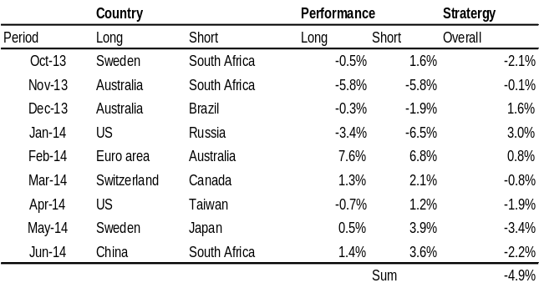
Source: J.P. Morgan
Table 2: Performance of systematic equity country model FX signal
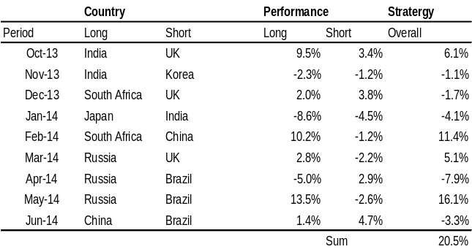
Source: J.P. Morgan

Table 3: Performance of systematic equity country model P/CF signal
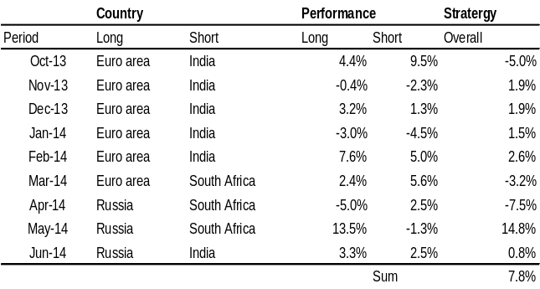
Source: J.P. Morgan

Long-Only Equity Portfolio
In this section we construct a long-only portfolio among the biggest and most liquid equity ETFs by incorporating our tactical views. This is different from the previous section where the focus is on long-short trade ideas, many of which are not accessible to long-only investors. But similar to the previous long-short equity portfolio, the sizes of the long only ETF trades are mostly a reflection of our confidence and do not take into account the correlations between different countries and sectors.
Our long-only portfolio selects among the 100 biggest equity ETFs by AUM. Table 5 shows the indices tracked by the 100 biggest equity ETFs along with the AUM.
Our benchmark long only equity portfolio is the universe of MSCI AC World equities. Deviations from this neutral or benchmark allocation of different countries or sectors generate different tracking errors. Table 4 shows these deviations along with tracking errors. The higher the tracking error, the higher the conviction we attach to a particular trading theme. 1% tracking error denotes low confidence, 2% denotes medium confidence and of 4% denotes high confidence.

Our allocation to equities focuses on sectoral and regional trades. The long-only equity portfolio is shown in Table 4. It uses liquid equity ETFs for transparency and simplicity in implementation.
Our main trading themes are OW EM via MSCI EM, OW the US via the S&P500/S&P Technology ETFs and OW Japan via J-REITs. In total, the tracking error of our recommended long-only is 3.7%.
Table 4: Recommended Long-Only Equity Portfolio
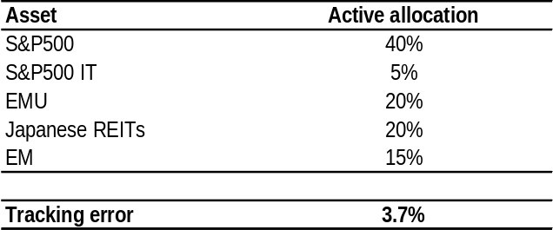
Source: J.P. Morgan

Table 2: Indices tracked by the 100 biggest ETFs along with the total AUM invested in these ETFs
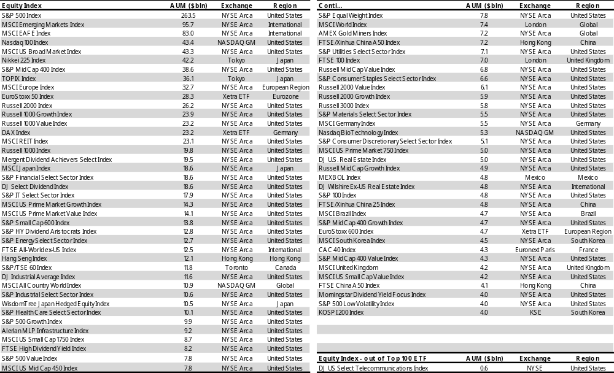
Source: J.P. Morgan. Note: AUM as of July 2, 2014.

Commodity Strategy
- Upgrade commodities to OW on attractive carry, rebounding manufacturing data in China, UW investor positions and supply risks in energy.
Stay OW oil markets as a hedge against a supply disruption and attractive carry but switch long in Brent into a long in the GSCI energy index on a better roll yield.
Stay long gasoline vs. heating oil on relative supply conditions.
Stay long sugar on weather risks.
- Keep long copper on continued improvement of Chinese demand.
Commodities are up around 3% since last GMOS, with energy and base metals up 4% and 7%, respectively, offsetting a 10% fall in agriculture. Fears of a supply disruption in Iraq pushed oil prices higher, while better Chinese activity data supported metals.
We have been UW commodities vs. credit and equities for the past three years, largely on weaker demand from EM and especially China as well as rising supply in many commodity markets. Over that period, commodity excess returns have been negative and investor interest in commodities has waned (Figure 1). According to data from Barclays, commodity assets under management across exchange-traded products (ETPs), commodity linked index products and MTNs have fallen from a peak of $430bn in 2012 to around $320bn at present. About a third of this decline was due to outflows from gold ETFs.
We moved our commodity allocation to OW in the J.P. Morgan View, Jun 13, and we maintain it. A number of major commodity futures curves are now in steep backwardation (downward sloping), offering very attractive carry. Supply is threatened in oil markets, inventories are low by historical standards, and Chinese activity data appear to have bottomed.
The NBS Chinese manufacturing PMI has now risen for four consecutive months and our China economist has revised up his Q2 GDP growth forecast from 6.8% saar to 7.2% saar. Targeted policy support for commodity intensive sectors like infrastructure is also supportive, especially for base metals. In fact, copper is up 6% over the last month. We have been long copper since early April (GMOS, Apr 9) as we thought the sell-off in March was overdone and our metal analysts were telling us there was strong physical
Figure 1: Long-only investment inflows into commodities
Includes ETPs, commodity linked index products and MTNs.
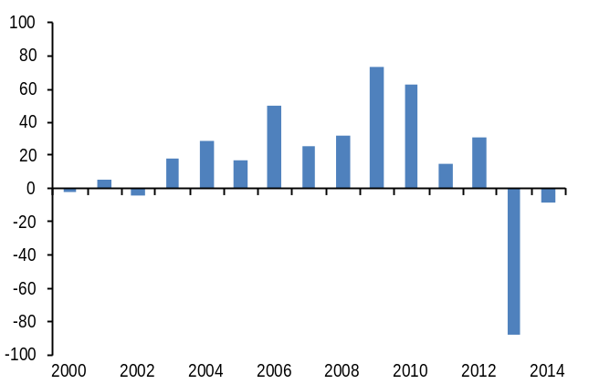
Source: Barclays.
Figure 2: Chinese manufacturing PMI base metal trading rule
Excess return index. The rule is long the GSCI base metals index when the 2-month change in the Chinese manufacturing PMI is positive and short when the 2-month change is negative.
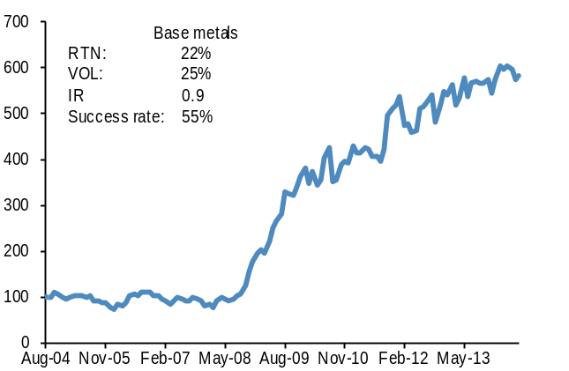
Source: J.P. Morgan, Bloomberg.
demand from China, outside the usual construction and housing related sectors. As we have shown in past GMOS, the Chinese manufacturing PMI has been a profitable indicator for trading base metals (Figure 2). A rule that is long the GSCI industrial metals index when the two-month change in the PMI is positive and goes short when the two-month change is negative, has produced a return to risk of 0.9 with a success rate of 55%, rebalancing monthly since 2004.
Another factor that has led investors to lower or eliminate their commodity allocation is the correlation to other asset classes in their portfolio. Commodities have historically been considered a good diversifier because of their consistently low correlation to equities and bonds. From 1988 to 2007, the correlation between weekly returns on the GSCI Light Energy index and the MSCI AC World index was 0.03 and vs. the Barclays US aggregate bond index was -0.06. Following the crisis in 2008, the correlation to equities jumped to around 0.80 and remained elevated until very recently. This year, it has fallen to around 0.13, within its historical range for the first time since before the financial crisis (Figure 3).
This fall is likely due to a combination of falling macro risks as we leave the crisis further behind and rising idiosyncratic commodity risks that are distinct from the risks driving equities. Oil markets have been increasingly supply driven over the last few years due to production losses in Libya, sanctions on Iran and now the threat of an outage in Iraq. In base metals, copper is trading almost entirely on expectations around Chinese growth, while nickel and aluminum are both driven by local supply issues. Agriculture markets are also trading completely independently of other commodities, largely on changes in weather expectations and the resulting implications for supply. We see no reason for this to change and so expect the correlation to stay low.
We continue to focus our commodity exposure on energy and copper. Oil production has been curtailed in Libya and is being threatened in Iraq. On our estimates, OPEC could make up for lost Iraqi production, but it would leave virtually no spare capacity. We are also just entering hurricane season and oil inventories are low, after having been depleted in the unusually cold winter. We thus think risks are biased to the upside for oil and we stay long. We switch our long in Brent into a long in the GSCI energy index as the combination of oil and oil products offers more attractive carry, while still providing a hedge against any production outage.
We keep our short in Nickel as the recent rally on the back of the Indonesian export ban has pushed prices to a level that should lead Chinese domestic inventories to be made available to the market (Metals Weekly: Nickel prices likely to correct further, Natasha Kaneva et al., May 27).
In agriculture, the probability of an El Niño materializing this year remains high. An El Niño is likely to be bad for crops in Asia and South America and may result in a weaker Indian monsoon, which would likely have a negative impact on the Indian sugar and cotton crops. It also has the potential to hit Brazilian and Thai sugar production later on; thus it would be a very bullish event for the sugar market. We stay long in Mar-15 sugar.
Figure 3: Commodity equity correlation
Rolling 52-week correlation of weekly returns on the GSCI Light Energy excess return index and MSCI AC World.
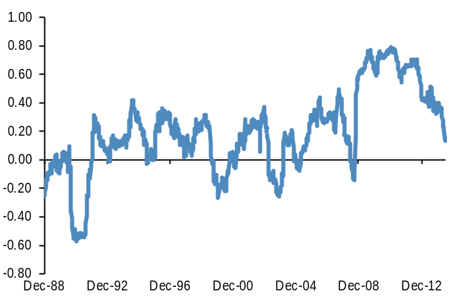
Source: Bloomberg, J.P. Morgan

Long-short commodity trades
- Switch long Brent into long GSCI energy ()
Oil and product forward curves are steeply backwardated, offering attractive roll returns. Additionally, we keep a long energy exposure as a hedge to our long risk positions elsewhere in the portfolio from any production outage in the Middle East.
- Long copper ()
Copper prices have rallied since we went long in early April and we think they have further to go. Chinese manufacturing data have surprised on the upside, with the PMI now rising for four consecutive months.
- Long Sep-14 gasoline vs. Sep-14 heating oil ()
Heating oil supply is likely to increase in the coming months as a large refinery in Saudi Arabia comes on line. In contrast, gasoline physical demand has picked up sharply over the last month and we expect this to continue. Inventories are also falling and relatively low and the shape of the two forward curves means this trade earns over 1% a month in roll.
- Short nickel ()
Nickel prices have rallied almost 40% YTD, following an export ban imposed by Indonesia. Although this has tightened the supply demand balance, we think the rally has gone too far and there are still relatively large inventories in China that will likely now be made available to the market.
- Long Mar-15 sugar ()
The rising risk of an El Niño this year is creating downside risk for sugar crop yields in Brazil, India and Thailand. We go long.

Long-only commodity portfolio
We complement our long-short portfolio with a portfolio of long-only commodity trades. This portfolio takes active positions in commodity futures. The aim is to produce an active return in excess of the return on the GSCI Light Energy index. The active allocations are based on the rationale laid out above in the commodity strategy section. The tables and figures below show the current allocations at a commodity and a commodity sector level.
This month in the long only commodity portfolio we maintain our focus on oil but we shift from Brent to the GSCI energy index as it has a more attractive roll yield. We move some weight from energy to copper given the improvement in the global and especially the Chinese PMI.
The tracking error of this active portfolio is 8% annualized, based on the past 6-months of daily returns.
Figure 4: Commodity long only allocations
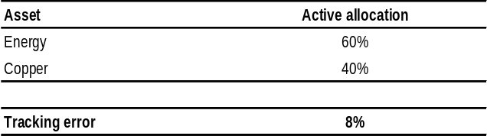
Source: J.P. Morgan
Figure 5: Commodity long-only portfolio performance
Excess returns. Alpha is the active return minus the benchmark return. Tracking error is ex-ante annualized. The benchmark is the GSCI light energy index.
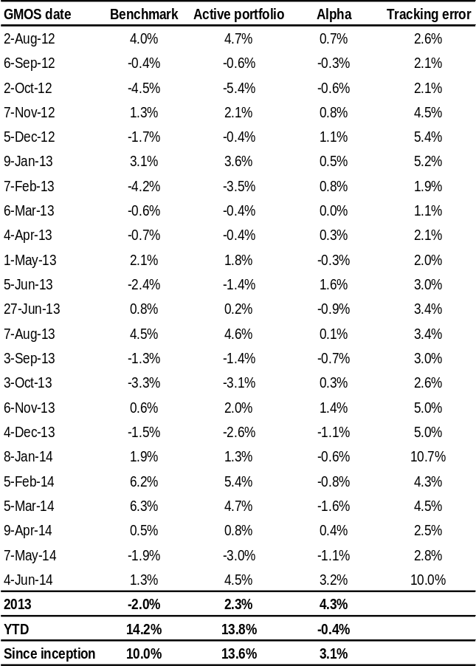
Source: J.P. Morgan

Volatility Strategy
Nikolaos Panigirtzoglou (44-20) 7134-7815
nikolaos.panigirtzoglou@jpmorgan.com
Matthias Bouquet (44-20) 7134-1819
matthias.bouquet@jpmorgan.com
Davide Silvestrini (44-20) 7134-4082
davide.silvestrini@jpmorgan.com
Joshua Younger (1-212) 270-1323
joshua.d.younger@jpmorgan.com

Khagendra Gupta (44-20) 7134-0486
khagendra.x.gupta@jpmorgan.com
Danny White (44-20) 7134-1812
danny.c.white@jpmorgan.com
Dominique Toublan (212) 834-2370
dominique.d.toublan@jpmorgan.com

- Stay with an overall short vol bias by selling 3-month straddles on CDX.HY.
- Open UK rate vol theme by buying front-end 2Y gamma vs. 10Y gamma.
- Keep long GBP vs. EUR gamma theme but switch from the 5Y sector to greens i.e. buy Dec14 2Y Short Sterling midcurve straddles versus selling a gamma equivalent amount of Dec14 2Y Euribor midcurve straddles.
- Keep US Credit vs. Rate Skew theme: long August expiry 25-delta payers and short 25-delta receivers on 5Y USD interest rate swaps versus the opposite structure in CDX.IG.
- Open European equities versus US high-grade theme: sell CDX.IG December payers to fund DAX OTM calls to position for a large upside event in European equities
- Keep Japanese relative value theme: take profit on Sep 14 USD/JPY put funded with a Nikkei put, and roll to 3M.
- Open long in Brent vs. Copper vol as we see upside risks to the former due to geopolitical developments.
- For investors looking for cheap tail risk hedges we continue to recommend four previous trades: 1) Long forward vols in G10 FX via FVAs. 2) Gold call contingent on S&P500. 3) 1y SEK/JPY put 10% OTMS and 4) 9m Dual At Expiry Digital EUR/USD down, Eurostoxx down, strikes 2% and 5% OTMS, respectively to monetize the drop in EUR/USD vs. Eurostoxx correlations.
- Implied volatilities continue to grind lower. Our cross-asset implied vol index shown in Figure 1 has posted a new low for the current cycle. Implied volatilities declined across all asset classes over the past month as shown in Figure 2.
- We maintain a short vol bias focusing on credit. Credit vols look more elevated than other asset classes not only vs. their range over the past year (see Table 1) but also vs. pre-crisis levels. In fact Table 1 shows that credit vols are the only ones within the 25%-75% percentile ranges over the past year. In addition, we note that credit offers the highest vol risk premia among asset classes; i.e. the highest implied to realized ratios, as shown in the last column of Table 1.
In this section, we focus on medium-term asset allocation across equity volatility, fixed income volatility, FX volatility, and commodity volatility. More detailed recommendations are presented in our sister publications, Equity Derivatives Markets Weekly Outlook, US Fixed Income Markets Weekly, Global Fixed Income Markets Weekly, FX Markets Weekly, Credit Markets Outlook and Strategy, and CD Player. We have argued previously that volatility can be viewed and traded much like any other asset class (see Volatility as an Asset Class, Terry Belton et al., and Variance Swaps, Marko Kolanovic et al). Declaring volatility an asset class is not obvious. The main asset classes around which we allocate strategically and tactically are stocks, bonds, credit, and commodities. FX is used largely for tactical allocation. Each of these provides returns in compensation for a distinct and identifiable type of risk. One aspect of risk common to each of these asset classes and around which investors can position is the high-frequency volatility of their prices. Many market participants indeed take views and positions on how volatile each of these asset classes will be in the future. One can, therefore, consider volatility a tactical asset class. The trades below reflect our top-down views on future asset class volatilities, relative to what is priced in option markets. We pay more attention to relative value volatility trades across asset classes.
Figure 1: Implied vol across 5 asset classes
Weighted average of 12 implied vols across 5 asset classes. We apply a 20% weight on each of the five asset classes. The 11 implied vols used were: V2X Index, VIX Index, VNKY Index, JPMVXYG7 Index, Cl1 Comdty, HG1 Comdty, GC1 Comdty, C 1 Comdty, iTraxx, CDX.IG, Euro 10y swap rate, US 10y swap rate.
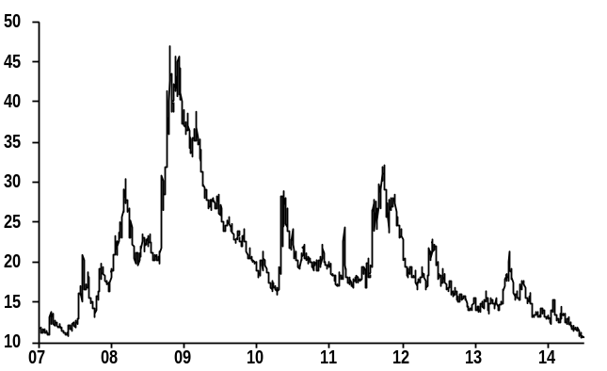
Source: Bloomberg, J.P. Morgan

Figure 2: Implied vol changes over the past month
Nikolaos Panigirtzoglou (44-20) 7134-7815
nikolaos.panigirtzoglou@jpmorgan.com
Matthias Bouquet (44-20) 7134-1819
matthias.bouquet@jpmorgan.com
Davide Silvestrini (44-20) 7134-4082
davide.silvestrini@jpmorgan.com
Joshua Younger (1-212) 270-1323
joshua.d.younger@jpmorgan.com

Khagendra Gupta (44-20) 7134-0486
khagendra.x.gupta@jpmorgan.com
Danny White (44-20) 7134-1812
danny.c.white@jpmorgan.com
Dominique Toublan (212) 834-2370
dominique.d.toublan@jpmorgan.com

Proportional change in implied vols in % since last publication on June 4th
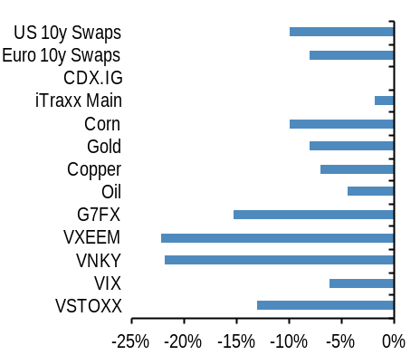 Source: Bloomberg, J.P. Morgan
- Our outright short position in 3-month straddles on iTraxx Senior Financials produced a small profit, 0.30% of notional. Given still elevated vol carry we keep a short credit vol stance but prefer to shift the exposure from iTraxx Senior Financials to CDX.HY where the implied to realized volatility ratio is higher at x1.7. That is we recommend selling 3-month straddles on CDX.HY index.
- Keep Credit vs. Rate Skew theme: stay long 25-delta 3Mx5Y USD swaption risk reversals versus CDX.IG risk reversals. We first recommended this trade in our April Cross Asset Volatility Strategy publication given the steep skew in CDX.IG and considerably flatter skew in the US rates market, and last month recommended rolling into August expiry options. Credit skew has flattened somewhat, but remains rich on a historical basis; rates skew, in the meantime, remains too flat both on a historical basis and relative to fair value (see discussion in Interest Rate Derivatives, US Fixed Income Markets Weekly, 6/27/14), in our view. Therefore, we continue to like this theme and recommend staying long August expiry 25-delta payers and short 25-delta receivers on 5Y USD interest rate swaps versus the opposite structure in CDX.IG (strikes 75bp/60bp on CDX and 2.08%/1.61% on 3Mx5Y swaptions).
- Keep Euro vs. UK rate theme: We have been recommending long GBP gamma vs. EUR gamma in the 5Y sector over the past few months. The ATMF implied volatility spread (using 6M options) has increased 0.3bp/day since we first recommended this trade. However, fixed strike and fixed dated implieds have declined to 0.7bp/day. This dynamic has been due to a 50bp decline in EUR swap rates which has lowered the ATMF volatility but the fixed strike implieds have
Figure 3: Hold long GBP vs. EUR gamma theme; close trade in 5Y and initiate long greens gamma in Short Sterling vs. Euribor gamma
Second greens (Short Sterling – Euribor) midcurve implied volatility spread regressed against 1) 2Yx1Y (SONIA – EONIA) yield spread and 2) 10D MA of EUR excess liquidity; past 1Y; bp/day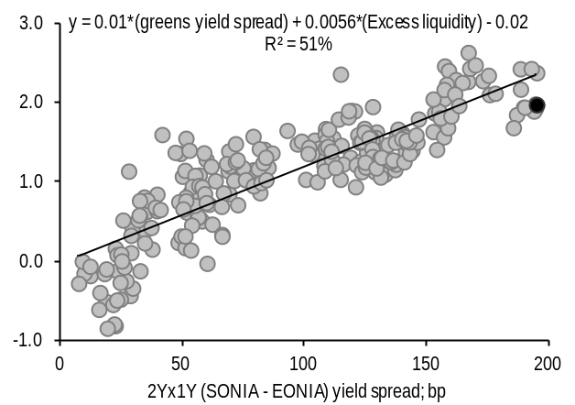Source: Bloomberg, J.P. Morgan
not declined proportionately as EUR payer skew has richened. Consequently, our trade has suffered losses despite the Carney-induced volatility in the GBP market. Despite this, we remain convinced that GBP gamma will outperform EUR gamma over the medium term and continue to prefer such trades. We switch our current trade (these options are only a month away from expiry) from the 5Y sector into greens expressed via options on the exchange in the greens part of the curve; buy Dec14 2Y Short Sterling midcurve straddles versus selling a gamma equivalent amount of Dec14 2Y Euribor midcurve straddles. This trade combines our bullish front-end GBP gamma and bearish front-end EUR gamma view (see 2014 Mid-year outlook). Finally, our view of a spread widening
(GBP – EUR) in the greens part is also supportive of higher implied volatility spread (Figure 3).
- Open UK rate vol theme, buy front-end gamma vs. 10Y gamma: The Bank of England’s policy path and the communication surrounding the onset and the subsequent pace of rate hikes will be the primary driver of volatility on the GBP curve over the next few months, in our view. Historically, the onset of central bank hiking had resulted in an increase in implied volatility across the volatility surface during both these episodes. However, outright long gamma positions were not necessarily profitable during these episodes as delivered volatility, although increased, stayed below implieds (see section on United Kingdom, Global Fixed Income Markets Weekly, 27 June 2014 for more details). Nevertheless, buying front-end gamma vs.
Figure 4: Buy front-end gamma versus intermediate tail gamma
Nikolaos Panigirtzoglou (44-20) 7134-7815
nikolaos.panigirtzoglou@jpmorgan.com
Matthias Bouquet (44-20) 7134-1819
matthias.bouquet@jpmorgan.com
Davide Silvestrini (44-20) 7134-4082
davide.silvestrini@jpmorgan.com
Joshua Younger (1-212) 270-1323
joshua.d.younger@jpmorgan.com

Khagendra Gupta (44-20) 7134-0486
khagendra.x.gupta@jpmorgan.com
Danny White (44-20) 7134-1812
danny.c.white@jpmorgan.com
Dominique Toublan (212) 834-2370
dominique.d.toublan@jpmorgan.com

(6Mx2Y – 6Mx10Y) implied vol spread, 3M delivered volatility spread*, and BoE base rate; bp/day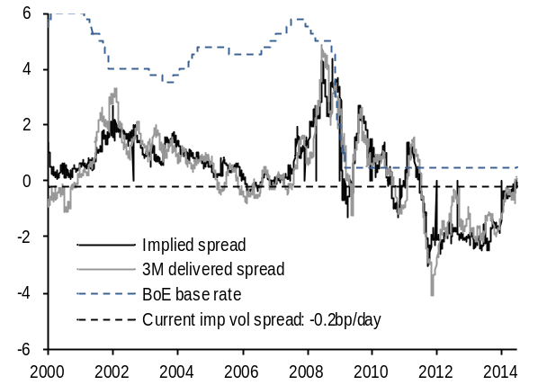
* Defined as 3M delivered volatility of 3Mx2Y GBP swap yield – 3M delivered volatility of 3Mx10Y GBP swap yield
Source: Bloomberg, J.P. Morgan
long end (i.e. buying 6Mx2Y vs. 6Mx10Y) has been profitable, on average, during these hiking cycles – a trend we expect to continue as volatility continues to move towards the front-end of the curve. Figure 4 shows the implied volatility spread (defined as 6Mx10Y – 6Mx2Y implied volatility) and 3M delivered volatility spread (defined as 3M delivered volatility of 10Y swaps – 3M delivered volatility of 2Y swaps). As we can see, implied volatility spread has increased recently, but is still below the lows of the previous hiking cycles. Similarly, the delivered volatility spread in the previous hiking cycles was generally above current levels of implied volatility spread, suggesting limited downside to this trade. Therefore, we would recommend buying front-end gamma (6Mx2Y) versus intermediate gamma (6Mx10Y).
- Open European Equities vs. US HG Credit theme: sell CDX.IG December 65bp payer to fund DAX OTM calls struck at 10,500. In the current low vol environment and expected pick-up in growth, we expect equities to outperform credit. Furthermore, the difference in the economic cycles should lead to Europe outperforming the US. The trade combines both views and takes advantage of the relatively high CDX implied volatility (with an implied to realized ratio at about 1.5x, close to a two-year high) and a lower European equity implied vol. Furthermore, while CDX.IG Series 22 is currently trading at 57bp, its level is expected to roll down the credit spread curve between now and December. Credit curves are steep and a 6m roll is worth about 7-8bp at the current levels. Also, the on-the-run index in December will be Series 23. Therefore,
Figure 5: USD/JPY dropped since inception of the conditional trade, while Nikkei rallied…
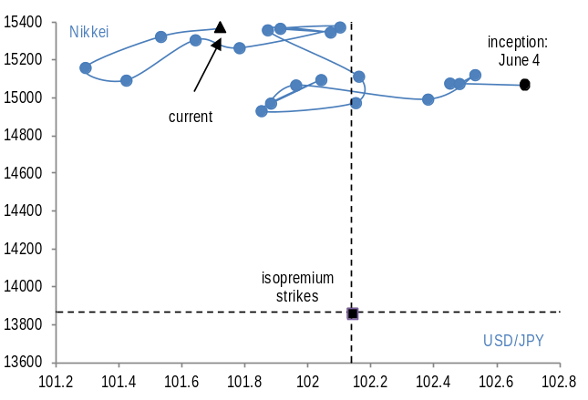
Source: Bloomberg, J.P. Morgan
Figure 6: Nikkei vs. USD/JPY
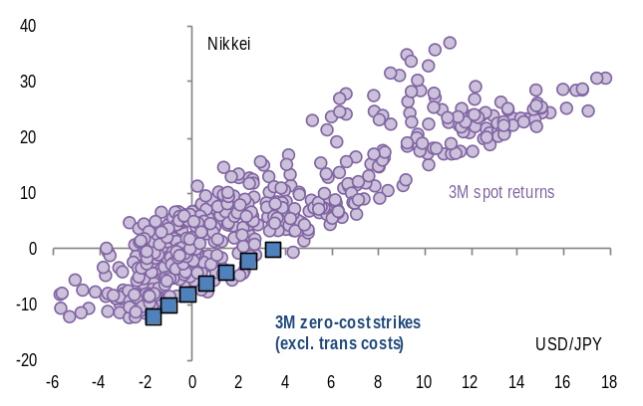
Source: Bloomberg, J.P. Morgan
most investors will likely use Series 23 than Series 22 to hedge for risk in 4Q14.
Selling €100mm equivalent of CDX IG Dec 65bp payers gives a premium of €305,000. This can be used to purchase 439 DAX Dec 10,500 calls. We see this as an attractive way to position for a large upside event in European equities, while taking advantage of both the steep rolldown and expensive implied volatility in CDX IG.
- Take profit on Sep 14 USD/JPY put funded with a Nikkei put, and roll to 3M. The trade initiated at zero-cost on June 4 returned 71bps PNL in just a month thanks to the combined rally in Nikkei (+2%) and drop in USD/JPY (-1.1%). See Figure 5 for the path followed by the two underlying since June 4th inception. The biggest contributor to PNL is the decay on the Nikkei put (+75bps), while the USD/JPY leg actually lost 4bps mostly due to the fall in FX vols. The setup of rich Nikkei puts relative to USD/JPY puts remains intact (Figure 6), therefore we take profit on this unusual combination of outcomes for Nikkei and USD/JPY, and roll the position with fresh 3M strikes. We fix the strike on the short Nikkei put at 90% of spot as of July 2nd, which allows us to fund a USD/JPY put 1.5% OTMS.
Khagendra Gupta (44-20) 7134-0486
khagendra.x.gupta@jpmorgan.com
Danny White (44-20) 7134-1812
danny.c.white@jpmorgan.com
Dominique Toublan (212) 834-2370
dominique.d.toublan@jpmorgan.com

- Open long in Brent vs. Copper vol as we see upside risks to the former due to geopolitical developments. Both vols spiked at the beginning of June but declined during the second half of the month. Geopolitical risks create upside for Brent oil price volatility in our mind, while Copper, which is more dependent on developments in China which are improving, should see further vol retracement from here. In addition, from a relative value point view, Brent vol seems too low vs. Copper vol based on a historical regression since the beginning of 2013 (Figure 7). Sell 3m straddles on Copper and buy 3m straddles on Brent oil, vega neutral with a ratio of 1:2.
Nikolaos Panigirtzoglou (44-20) 7134-7815
nikolaos.panigirtzoglou@jpmorgan.com
Matthias Bouquet (44-20) 7134-1819
matthias.bouquet@jpmorgan.com
Davide Silvestrini (44-20) 7134-4082
davide.silvestrini@jpmorgan.com
Joshua Younger (1-212) 270-1323
joshua.d.younger@jpmorgan.com

- Jun-14 SX7E Calls funded by selling iTraxx Main Receivers expired at a loss: we previously (May 7th) recommended buying SX7E Jun-14 150 calls and funding the trade by selling iTraxx Senior Financials June 80bp receivers. On the iTraxx Fin Senior leg we lost €888,000 and only made €295,944 on the equity leg, given a total loss of €592,056. Litigation issues with European banks weighed heavily on this trade.
- TAIL RISK HEDGES: For investors who are long risky assets and look for cheap tail-risk hedges to a potential equity market correction, we continue to recommend three trades:
- 1) Monetize the drop in EUR/USD vs. Eurostoxx correlations by entering a 9M Dual At Expiry Digital EUR/USD down, Eurostoxx down, strikes 2% and 5% OTMS, respectively. The correlation between daily returns in EUR/USD and Eurostoxx, as well as with S&P500, has dropped to historical lows. Anecdotally, hybrids markets have seen good investor interest for structures, whereby the buyer is short correlation, typically betting for a ECB QE-fuelled rally in equities and a drop in EUR/USD. This cheapness in correlations is conducive to tail-risk strategies that play for a pickup in correlations and a combined rally in USD and drop in risky assets.
- 2) Long forward vols in G10 FX via FVAs where the cost of carry was minimal. In particular, the flatness in FX vol curves offers an efficient way to be long vol through FVAs. There is minimal cost with carrying this long term hedge. We hold a long basket of 9Mx3M FVAs in USD/NOK, USD/SEK, EUR/NOK, EUR/SEK, EUR/USD, GBP/USD, and EUR/JPY, as a long vega
Figure 7: 3m implied vol on Brent (y axis) vs. Copper (x-axis) in %
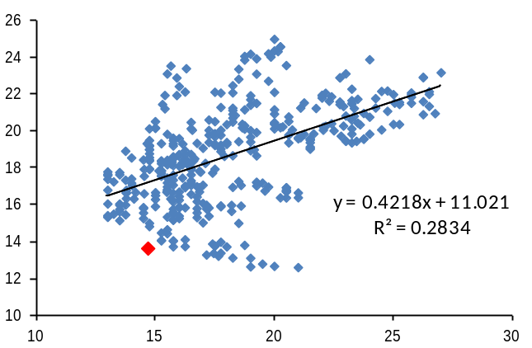
Source: Bloomberg, J.P. Morgan
hedge against a move higher in vols. This position has been negatively impacted from the drop in vols near historical lows; our JPM VXY Global FX vol index has dropped to 5.4 at the end of June. But the position has suffered less than outright long positions in spot vols, and should have limited downside from current lows.
- 3) Long GLD calls contingent on SPX as a cheap tail risk hedge. A potential flight to quality episode should boost gold prices at the same time as equities come under pressure. However, markets are currently pricing in modestly negative (-10%) implied correlation between the two, and we recommend using this mispricing to fund a flight to quality hedge: buy 3-month 105% GLD calls contingent on a 2% decline in SPX for a premium of 45bp, or a roughly 55% discount to vanilla calls. Since the beginning of 2010, when equities fell more than 2% over a three month period GLD rallied more than 5% approximately two-thirds of the time (average gain of roughly 8%).Given the likelihood that the option will be exercisable if tail risk rises, and a significant discount to vanilla calls, such trades are currently attractive as a cheap hedge, in our view.
- 4) Long 1y SEK/JPY put. Although Equity vols have come off recently, FX vols remain nominally cheaper. Our JPM VXY Global FX vol index is close to 6.0 while VIX is above 12.0. Among the FX pairs exhibiting high correlation with equities, we had identified SEK/JPY as the most attractive pair to own a put on, as a proxy hedge for a drop in the S&P500 index. Indeed, the pair shows a consistent correlation with S&P500 returns, and the cost of a 1y put, with strike adjusted according to the beta of 1y returns with the S&P500 index, is among the cheapest across FX pairs. We recommend a 1Y SEK/JPY Put, strike 13.9 (=10% OTMS at spot ref 15.45).

Nikolaos Panigirtzoglou (44-20) 7134-7815
nikolaos.panigirtzoglou@jpmorgan.com
Matthias Bouquet (44-20) 7134-1819
matthias.bouquet@jpmorgan.com
Davide Silvestrini (44-20) 7134-4082
davide.silvestrini@jpmorgan.com
Joshua Younger (1-212) 270-1323
joshua.d.younger@jpmorgan.com
Khagendra Gupta (44-20) 7134-0486
khagendra.x.gupta@jpmorgan.com
Danny White (44-20) 7134-1812
danny.c.white@jpmorgan.com
Dominique Toublan (212) 834-2370
dominique.d.toublan@jpmorgan.com

Table 1: Cross Asset Volatility Monitor - 3m ATM Implied Volatility (1y history) as of 1-Jul-14
This table shows the richness/cheapness of current implied volatility levels (red dot) against their 1 year historical range (thin blue bar) and the ratio to current realized volatility. Assets with implied volatility outside their 25th/75th percentile range (thick blue bar) are highlighted.
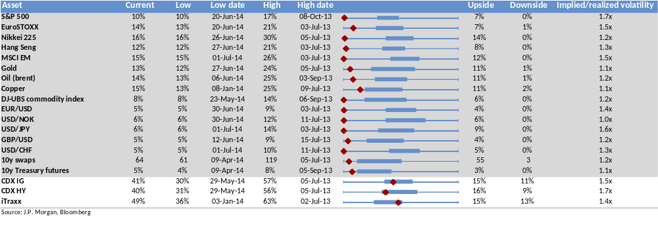
Note: Swaps volatility is 3m 10y payer ATMF implied annualized BP vol and credit volatility is 3m 5y on-the-run ATM spread volatility. MSCI EM and Treasury futures are 3m implied vol from Bloomberg.
Definitions:
Low: Lowest closing level in the last 1y
Low date: Date the lowest closing level was reached (or the first time it was reached in the case of several identical low closing levels)
High: Highest closing level in the last 1y
High date: Date the highest closing level was reached (or the first time it was reached in the case of several identical high closing levels)
Graph: Shows the current level and the 25th/75th percentile relative to the 1y high/low
Upside: Implied return/volatility percentage points from current level up to the High (note: return is calculated as simple difference for spread products)
Downside: Implied return/volatility percentage points from current level down to the Low (note: return calculated as simple difference for spread products)
Implied/realized volatility: Current 3m implied volatility / current realized 3m volatility

This page is intentionally left blank

This page is intentionally left blank

Risks of Common Option Strategies
Risks to Strategies: Not all option strategies are suitable for investors; certain strategies may expose investors to significant potential losses. We have summarized the risks of selected derivative strategies. For additional risk information, please call your sales representative for a copy of “Characteristics and Risks of Standardized Options.” We advise investors to consult their tax advisors and legal counsel about the tax implications of these strategies. Please also refer to option risk disclosure documents.
Put Sale. Investors who sell put options will own the underlying asset if the asset’s price falls below the strike price of the put option. Investors, therefore, will be exposed to any decline in the underlying asset’s price below the strike potentially to zero, and they will not participate in any price appreciation in the underlying asset if the option expires unexercised.
Call Sale. Investors who sell uncovered call options have exposure on the upside that is theoretically unlimited.
Call Overwrite or Buywrite. Investors who sell call options against a long position in the underlying asset give up any appreciation in the underlying asset’s price above the strike price of the call option, and they remain exposed to the downside of the underlying asset in the return for the receipt of the option premium.
Booster. In a sell-off, the maximum realized downside potential of a double-up booster is the net premium paid. In a rally, option losses are potentially unlimited as the investor is net short a call. When overlaid onto a long position in the underlying asset, upside losses are capped (as for a covered call), but downside losses are not.
Collar. Locks in the amount that can be realized at maturity to a range defined by the put and call strike. If the collar is not costless, investors risk losing 100% of the premium paid. Since investors are selling a call option, they give up any price appreciation in the underlying asset above the strike price of the call option.
Call Purchase. Options are a decaying asset, and investors risk losing 100% of the premium paid if the underlying asset’s price is below the strike price of the call option.
Put Purchase. Options are a decaying asset, and investors risk losing 100% of the premium paid if the underlying asset’s price is above the strike price of the put option.
Straddle or Strangle. The seller of a straddle or strangle is exposed to increases in the underlying asset’s price above the call strike and declines in the underlying asset’s price below the put strike. Since exposure on the upside is theoretically unlimited, investors who also own the underlying asset would have limited losses should the underlying asset rally. Covered writers are exposed to declines in the underlying asset position as well as any additional exposure should the underlying asset decline below the strike price of the put option. Having sold a covered call option, the investor gives up all appreciation in the underlying asset above the strike price of the call option.
Put Spread. The buyer of a put spread risks losing 100% of the premium paid. The buyer of higher-ratio put spread has unlimited downside below the lower strike (down to zero), dependent on the number of lower-struck puts sold. The maximum gain is limited to the spread between the two put strikes, when the underlying is at the lower strike. Investors who own the underlying asset will have downside protection between the higher-strike put and the lower-strike put. However, should the underlying asset’s price fall below the strike price of the lower-strike put, investors regain exposure to the underlying asset, and this exposure is multiplied by the number of puts sold.
Call Spread. The buyer risks losing 100% of the premium paid. The gain is limited to the spread between the two strike prices. The seller of a call spread risks losing an amount equal to the spread between the two call strikes less the net premium received. By selling a covered call spread, the investor remains exposed to the downside of the underlying asset and gives up the spread between the two call strikes should the underlying asset rally.
Butterfly Spread. A butterfly spread consists of two spreads established simultaneously – one a bull spread and the other a bear spread. The resulting position is neutral, that is, the investor will profit if the underlying is stable. Butterfly spreads are established at a net debit. The maximum profit will occur at the middle strike price; the maximum loss is the net debit.
Pricing Is Illustrative Only: Prices quoted in the above trade ideas are our estimate of current market levels, and are not indicative trading levels.

Disclosures

This report is a product of the research department's Global Equity Derivatives and Delta One Strategy group. Views expressed may differ from the views of the research analysts covering stocks or sectors mentioned in this report. Structured securities, options, futures and other derivatives are complex instruments, may involve a high degree of risk, and may be appropriate investments only for sophisticated investors who are capable of understanding and assuming the risks involved. Because of the importance of tax considerations to many option transactions, the investor considering options should consult with his/her tax advisor as to how taxes affect the outcome of contemplated option transactions.

Analyst Certification: The research analyst(s) denoted by an “AC” on the cover of this report certifies (or, where multiple research analysts are primarily responsible for this report, the research analyst denoted by an “AC” on the cover or within the document individually certifies, with respect to each security or issuer that the research analyst covers in this research) that: (1) all of the views expressed in this report accurately reflect his or her personal views about any and all of the subject securities or issuers; and (2) no part of any of the research analyst's compensation was, is, or will be directly or indirectly related to the specific recommendations or views expressed by the research analyst(s) in this report. For all Korea-based research analysts listed on the front cover, they also certify, as per KOFIA requirements, that their analysis was made in good faith and that the views reflect their own opinion, without undue influence or intervention.

Company-Specific Disclosures: Important disclosures, including price charts, are available for compendium reports and all J.P. Morgan–covered companies by visiting https://jpmm.com/research/disclosures, calling 1-800-477-0406, or e-mailing research.disclosure.inquiries@jpmorgan.com with your request. J.P. Morgan’s Strategy, Technical, and Quantitative Research teams may screen companies not covered by J.P. Morgan. For important disclosures for these companies, please call 1-800-477-0406 or e-mail research.disclosure.inquiries@jpmorgan.com.

Analysts' Compensation: The research analysts responsible for the preparation of this report receive compensation based upon various factors, including the quality and accuracy of research, client feedback, competitive factors, and overall firm revenues.

Other Disclosures

Analysts' Compensation: The research analysts responsible for the preparation of this report receive compensation based upon various factors, including the quality and accuracy of research, client feedback, competitive factors, and overall firm revenues. Principal Trading: JPMorgan and/or its affiliates normally make a market and trade as principal in fixed income securities discussed in this report. Legal Entities: J.P. Morgan is the global brand name for J.P. Morgan Securities LLC (JPMS) and its non-US affiliates worldwide. J.P. Morgan Cazenove is a brand name for equity research produced by J.P. Morgan Securities plc; J.P. Morgan Equities South Africa Proprietary Limited; JPMorgan Chase Bank, N.A., Dubai Branch; and J.P. Morgan Bank International LLC. J.P.Morgan Securities Inc. is a member of NYSE and SIPC. JPMorgan Chase Bank, N.A. is a member of FDIC. U.K.: JPMorgan Chase N.A., London Branch, is authorised by the Prudential Regulation Authority and is subject to regulation by the Financial Conduct Authority and to limited regulation by the Prudential Regulation Authority. Details about the extent of our regulation by the Prudential Regulation Authority are available from J.P. Morgan on request. J.P. Morgan Securities plc (JPMS plc) is a member of the London Stock Exchange and is authorised by the Prudential Regulation Authority and regulated by the Financial Conduct Authority and the Prudential Regulation Authority. J.P. Morgan Equities South Africa Proprietary Limited is a member of the Johannesburg Securities Exchange and is regulated by the Financial Services Board. J.P. Morgan Securities (Asia Pacific) Limited (CE number AAJ321) is regulated by the Hong Kong Monetary Authority. JPMorgan Chase Bank, N.A., Singapore branch and J.P. Morgan Securities Singapore Private Limited are regulated by the Monetary Authority of Singapore. JPMorgan Securities Japan Co., Ltd. is regulated by the Financial Services Agency in Japan. J.P. Morgan Australia Limited (JPMAL) (ABN 52 002 888 011/AFS Licence No: 238188) is regulated by ASIC and J.P. Morgan Securities Australia Limited (JPMSAL) (ABN 61 003 245 234/AFS Licence No: 238066) is regulated by ASIC and is a Market, Clearing and Settlement Participant of ASX Limited and CHI-X. J.P.Morgan Saudi Arabia Ltd. is authorized by the Capital Market Authority of the Kingdom of Saudi Arabia (CMA), licence number 35-07079. General: Information has been obtained from sources believed to be reliable but JPMorgan does not warrant its completeness or accuracy except with respect to disclosures relative to JPMS and/or its affiliates and the analyst’s involvement with the issuer. Opinions and estimates constitute our judgment at the date of this material and are subject to change without notice. Past performance is not indicative of future results. The investments and strategies discussed may not be suitable for all investors; if you have any doubts you should consult your investment advisor. The investments discussed may fluctuate in price or value. Changes in rates of exchange may have an adverse effect on the value of investments. This material is not intended as an offer or solicitation for the purchase or sale of any financial instrument. JPMorgan and/or its affiliates and employees may act as placement agent, advisor or lender with respect to securities or issuers referenced in this report.. Clients should contact analysts at and execute transactions through a JPMorgan entity in their home jurisdiction unless governing law permits otherwise. This report should not be distributed to others or replicated in any form without prior consent of JPMorgan. U.K. and European Economic Area (EEA): Investment research issued by JPMS plc has been prepared in accordance with JPMS plc’s Policies for Managing Conflicts of Interest in Connection with Investment Research. This report has been issued in the U.K. only to persons of a kind described in Article 19 (5), 38, 47 and 49 of the Financial Services and Markets Act 2000 (Financial Promotion) Order 2001 (all such persons being referred to as “relevant persons”). This document must not be acted on or relied on by persons who are not relevant. Any investment or investment activity to which this document relates is only available to relevant persons and will be engaged in only with these persons. In other EEA countries, the report has been issued to persons regarded as professional investors (or equivalent) in their home jurisdiction. Japan: There is a risk that a loss may occur due to a change in the price of the shares in the case of share trading, and that a loss may occur due to the exchange rate in the case of foreign share trading. In the case of share trading, JPMorgan Securities Japan Co., Ltd., will be receiving a brokerage fee and consumption tax (shouhizei) calculated by multiplying the executed price by the commission rate which was individually agreed between JPMorgan Securities Japan Co., Ltd., and the customer in advance. Financial Instruments Firms: JPMorgan Securities Japan Co., Ltd., Kanto Local Finance Bureau (kinsho) No. 82 Participating Association / Japan Securities Dealers Association, The Financial Futures Association of Japan, Type II Financial Instruments Firms Association and Japan Investment Advisers Association. Australia: This material is issued and distributed by JPMSAL in Australia to “wholesale clients” only. This material does not take into account the specific investment objectives, financial situation or particular needs of the recipient. The recipient of this material must not distribute it to any third party or outside Australia without the prior written consent of JPMSAL. For the purposes of this paragraph the term “wholesale client” has the meaning given in section 761G of the Corporations Act 2001. New Zealand: This material is issued and distributed by JPMSAL in New Zealand only to persons whose principal business is the investment of money or who, in the course of and for the purposes of their business, habitually invest money. JPMSAL does not issue or distribute this material to members of "the public" as determined in accordance with section 3 of the Securities Act 1978. The recipient of this material must not distribute it to any third party or outside New Zealand without the prior written consent of JPMSAL. Canada: The information contained herein is not, and under no circumstances is to be construed as, a prospectus, an advertisement, a public offering, an offer to sell securities described herein, or solicitation of an offer to buy securities described herein, in Canada or any province or territory thereof. Any offer or sale of the securities described herein in Canada will be made only under an exemption from the requirements to file a prospectus with the relevant Canadian securities regulators and only by a dealer properly registered under applicable securities laws or, alternatively, pursuant to an exemption from the dealer registration requirement in the relevant province or territory of Canada in which such offer or sale is made. The information contained herein is under no circumstances to be construed as investment advice in any province or territory of Canada and is not tailored to the needs of the recipient. To the extent that the information contained herein references securities of an issuer incorporated, formed or created under the laws of Canada or a province or territory of Canada, any trades in such securities must be conducted through a dealer registered in Canada. No securities commission or similar regulatory authority in Canada has reviewed or in any way passed judgment upon these materials, the information contained herein or the merits of the securities described herein, and any representation to the contrary is an offense. Korea: This report may have been edited or contributed to from time to time by affiliates of J.P. Morgan Securities (Far East) Ltd, Seoul branch. Brazil: Ombudsman J.P. Morgan: 0800-7700847 / ouvidoria.jp.morgan@jpmorgan.com. Revised April 5, 2014. Copyright 2014 JPMorgan Chase Co. All rights reserved. Additional information available upon request. J.P. Morgan ("JPM") is the global brand name for J.P. Morgan Securities LLC ("JPMS") and its affiliates worldwide. J.P. Morgan Cazenove is a marketing name for the U.K. investment banking businesses and EMEA cash equities and equity research businesses of JPMorgan Chase & Co. and its subsidiaries.

Options related research: If the information contained herein regards options related research, such information is available only to persons who have received the proper option risk disclosure documents. For a copy of the Option Clearing Corporation's Characteristics and Risks of Standardized Options, please contact your J.P. Morgan Representative or visit the OCC's website at http://www.optionsclearing.com/publications/risks/riskstoc.pdf

Legal Entities Disclosures
U.S.: JPMS is a member of NYSE, FINRA, SIPC and the NFA. JPMorgan Chase Bank, N.A. is a member of FDIC. U.K.: JPMorgan Chase N.A., London Branch, is authorised by the Prudential Regulation Authority and is subject to regulation by the Financial Conduct Authority and to limited regulation by the Prudential Regulation Authority. Details about the extent of our regulation by the Prudential Regulation Authority are available from J.P. Morgan on request. J.P. Morgan Securities plc (JPMS plc) is a member of the London Stock Exchange and is authorised by the Prudential Regulation Authority and regulated by the Financial Conduct Authority and the Prudential Regulation Authority. Registered in England & Wales No. 2711006. Registered Office 25 Bank Street, London, E14 5JP. South Africa: J.P. Morgan Equities South Africa Proprietary Limited is a member of the Johannesburg Securities Exchange and is regulated by the Financial Services Board. Hong Kong: J.P. Morgan Securities (Asia Pacific) Limited (CE number AAJ321) is regulated by the Hong Kong Monetary Authority and the Securities and Futures Commission in Hong Kong and/or J.P. Morgan Broking (Hong Kong) Limited (CE number AAB027) is regulated by the Securities and Futures Commission in Hong Kong. Korea: J.P. Morgan Securities (Far East) Ltd, Seoul Branch, is regulated by the Korea Financial Supervisory Service. Australia: J.P. Morgan Australia Limited (JPMAL) (ABN 52 002 888 011/AFS Licence No: 238188) is regulated by ASIC and J.P. Morgan Securities Australia Limited (JPMSAL) (ABN 61 003 245 234/AFS Licence No: 238066) is regulated by ASIC and is a Market, Clearing and Settlement Participant of ASX Limited and CHI-X. Taiwan: J.P.Morgan Securities (Taiwan) Limited is a participant of the Taiwan Stock Exchange (company-type) and regulated by the Taiwan Securities and Futures Bureau. India: J.P. Morgan India Private Limited (Corporate Identity Number - U67120MH1992FTC068724), having its registered office at J.P. Morgan Tower, Off. C.S.T. Road, Kalina, Santacruz - East, Mumbai – 400098, is a member of the National Stock Exchange of India Limited (SEBI Registration Number - INB 230675231/INF 230675231/INE 230675231) and Bombay Stock Exchange Limited (SEBI Registration Number - INB 010675237/INF 010675237) and is regulated by Securities and Exchange Board of India. Telephone: 91-22-6157 3000, Facsimile: 91-22-6157 3990 and Website: www.jpmipl.com. For non local research reports, this material is not distributed in India by J.P. Morgan India Private Limited. Thailand: This material is issued and distributed in Thailand by JPMorgan Securities (Thailand) Ltd., which is a member of the Stock Exchange of Thailand and is regulated by the Ministry of Finance and the Securities and Exchange Commission and its registered address is 3rd Floor, 20 North Sathorn Road, Silom, Bangrak, Bangkok 10500. Indonesia: PT J.P. Morgan Securities Indonesia is a member of the Indonesia Stock Exchange and is regulated by the OJK a.k.a. BAPEPAM LK. Philippines: J.P. Morgan Securities Philippines Inc. is a Trading Participant of the Philippine Stock Exchange and a member of the Securities Clearing Corporation of the Philippines and the Securities Investor Protection Fund. It is regulated by the Securities and Exchange Commission. Brazil: Banco J.P. Morgan S.A. is regulated by the Comissao de Valores Mobiliarios (CVM) and by the Central Bank of Brazil. Mexico: J.P. Morgan Casa de Bolsa, S.A. de C.V., J.P. Morgan Grupo Financiero is a member of the Mexican Stock Exchange and authorized to act as a broker dealer by the National Banking and Securities Exchange Commission. Singapore: This material is issued and distributed in Singapore by or through J.P. Morgan Securities Singapore Private Limited (JPMSS) [MCI (P) 199/03/2014 and Co. Reg. No.: 199405335R] which is a member of the Singapore Exchange Securities Trading Limited and is regulated by the Monetary Authority of Singapore (MAS) and/or JPMorgan Chase Bank, N.A., Singapore branch (JPMCB Singapore) which is regulated by the MAS. This material is provided in Singapore only to accredited investors, expert investors and institutional investors, as defined in Section 4A of the Securities and Futures Act, Cap. 289. Recipients of this document are to contact JPMSS or JPMCB Singapore in respect of any matters arising from, or in connection with, the document. Japan: JPMorgan Securities Japan Co., Ltd. is regulated by the Financial Services Agency in Japan. Malaysia: This material is issued and distributed in Malaysia by JPMorgan Securities (Malaysia) Sdn Bhd (18146-X) which is a Participating Organization of Bursa Malaysia Berhad and a holder of Capital Markets Services License issued by the Securities Commission in Malaysia. Pakistan: J. P. Morgan Pakistan Broking (Pvt.) Ltd is a member of the Karachi Stock Exchange and regulated by the Securities and Exchange Commission of Pakistan. Saudi Arabia: J.P. Morgan Saudi Arabia Ltd. is authorized by the Capital Market Authority of the Kingdom of Saudi Arabia (CMA) to carry out dealing as an agent, arranging, advising and custody, with respect to securities business under licence number 35-07079 and its registered address is at 8th Floor, Al-Faisaliyah Tower, King Fahad Road, P.O. Box 51907, Riyadh 11553, Kingdom of Saudi Arabia. Dubai: JPMorgan Chase Bank, N.A., Dubai Branch is regulated by the Dubai Financial Services Authority (DFSA) and its registered address is Dubai International Financial Centre - Building 3, Level 7, PO Box 506551, Dubai, UAE.

Country and Region Specific Disclosures
U.K. and European Economic Area (EEA): Unless specified to the contrary, issued and approved for distribution in the U.K. and the EEA by JPMS plc. Investment research issued by JPMS plc has been prepared in accordance with JPMS plc's policies for managing conflicts of interest arising as a result of publication and distribution of investment research. Many European regulators require a firm to establish, implement and maintain such a policy. This report has been issued in the U.K. only to persons of a kind described in Article 19 (5), 38, 47 and 49 of the Financial Services and Markets Act 2000 (Financial Promotion) Order 2005 (all such persons being referred to as "relevant persons"). This document must not be acted on or relied on by persons who are not relevant persons. Any investment or investment activity to which this document relates is only available to relevant persons and will be engaged in only with relevant persons. In other EEA countries, the report has been issued to persons regarded as professional investors (or equivalent) in their home jurisdiction. Australia: This material is issued and distributed by JPMSAL in Australia to "wholesale clients" only. This material does not take into account the specific investment objectives, financial situation or particular needs of the recipient. The recipient of this material must not distribute it to any third party or outside Australia without the prior written consent of JPMSAL. For the purposes of this paragraph the term "wholesale client" has the meaning given in section 761G of the Corporations Act 2001. Germany: This material is distributed in Germany by J.P. Morgan Securities plc, Frankfurt Branch and J.P.Morgan Chase Bank, N.A., Frankfurt Branch which are regulated by the Bundesanstalt für Finanzdienstleistungsaufsicht. Hong Kong: The 1% ownership disclosure as of the previous month end satisfies the requirements under Paragraph 16.5(a) of the Hong Kong Code of Conduct for Persons Licensed by or Registered with the Securities and Futures Commission. (For research published within the first ten days of the month, the disclosure may be based on the month end data from two months prior.) J.P. Morgan Broking (Hong Kong) Limited is the liquidity provider/market maker for derivative warrants, callable bull bear contracts and stock options listed on the Stock Exchange of Hong Kong Limited. An updated list can be found on HKEx website: http://www.hkex.com.hk. Japan: There is a risk that a loss may occur due to a change in the price of the shares in the case of share trading, and that a loss may occur due to the exchange rate in the case of foreign share trading. In the case of share trading, JPMorgan Securities Japan Co., Ltd., will be receiving a brokerage fee and consumption tax (shouhizei) calculated by multiplying the executed price by the commission rate which was individually agreed between JPMorgan Securities Japan Co., Ltd., and the customer in advance. Financial Instruments Firms: JPMorgan Securities Japan Co., Ltd., Kanto Local Finance Bureau (kinsho) No. 82 Participating Association / Japan Securities Dealers Association, The Financial Futures Association of Japan, Type II Financial Instruments Firms Association and Japan Investment Advisers Association. Korea: This report may have been edited or contributed to from time to time by affiliates of J.P. Morgan Securities (Far East) Ltd, Seoul Branch. Singapore: JPMSS and/or its affiliates may have a holding in any of the securities discussed in this report; for securities where the holding is 1% or greater, the specific holding is disclosed in the Important Disclosures section above. India: For private circulation only, not for sale. Pakistan: For private circulation only, not for sale. New Zealand: This material is issued and distributed by JPMSAL in New Zealand only to persons whose principal business is the investment of money or who, in the course of and for the purposes of their business, habitually invest money. JPMSAL does not issue or distribute this material to members of "the public" as determined in accordance with section 3 of the Securities Act 1978. The recipient of this material must not distribute it to any third party or outside New Zealand without the prior written consent of JPMSAL. Canada: The information contained herein is not, and under no circumstances is to be construed as, a prospectus, an advertisement, a public offering, an offer to sell securities described herein, or solicitation of an offer to buy securities described herein, in Canada or any province or territory thereof. Any offer or sale of the securities described herein in Canada will be made only under an exemption from the requirements to file a prospectus with the relevant Canadian securities regulators and only by a dealer properly registered under applicable securities laws or, alternatively, pursuant to an exemption from the dealer registration requirement in the relevant province or territory of Canada in which such offer or sale is made. The information contained herein is under no circumstances to be construed as investment advice in any province or territory of Canada and is not tailored to the needs of the recipient. To the extent that the information contained herein references securities of an issuer incorporated, formed or created under the laws of Canada or a province or territory of Canada, any trades in such securities must be conducted through a dealer registered in Canada. No securities commission or similar regulatory authority in Canada has reviewed or in any way passed judgment upon these materials, the information contained herein or the merits of the securities described herein, and any representation to the contrary is an offence. Dubai: This report has been issued to persons regarded as professional clients as defined under the DFSA rules. Brazil: Ombudsman J.P. Morgan: 0800-7700847 / ouvidoria.jp.morgan@jpmorgan.com.

General: Additional information is available upon request. Information has been obtained from sources believed to be reliable but JPMorgan Chase & Co. or its affiliates and/or subsidiaries (collectively J.P. Morgan) do not warrant its completeness or accuracy except with respect to any disclosures relative to JPMS and/or its affiliates and the analyst's involvement with the issuer that is the subject of the research. All pricing is as of the close of market for the securities discussed, unless otherwise stated. Opinions and estimates constitute our judgment as of the date of this material and are subject to change without notice. Past performance is not indicative of future results. This material is not intended as an offer or solicitation for the purchase or sale of any financial instrument. The opinions and recommendations herein do not take into account individual client circumstances, objectives, or needs and are not intended as recommendations of particular securities, financial instruments or strategies to particular clients. The recipient of this report must make its own independent decisions regarding any securities or financial instruments mentioned herein. JPMS distributes in the U.S. research published by non-U.S. affiliates and accepts responsibility for its contents. Periodic updates may be provided on companies/industries based on company specific developments or announcements, market conditions or any other publicly available information. Clients should contact analysts and execute transactions through a J.P. Morgan subsidiary or affiliate in their home jurisdiction unless governing law permits otherwise.

"Other Disclosures" last revised June 21, 2014.

Copyright 2014 JPMorgan Chase & Co. All rights reserved. This report or any portion hereof may not be reprinted, sold or redistributed without the written consent of J.P. Morgan. #$J&098$#*P

For background on JPM’s global inflation view, click these two hyperlinked articles from the weekly Global Data Watch: Global disinflation is about to take a breather (April 11, 2014) and As the inflation cycle turns (May 16, 2014).
Click this hyperlink for the most recent edition of Monthly Inflation Outlook published June 11, 2014 by Francis Diamond et al.
A shortcoming of PPP is that it assumes that investors respond to inflation rather than respond to the risk premium like real yields which they are paid to tolerate inflation.

